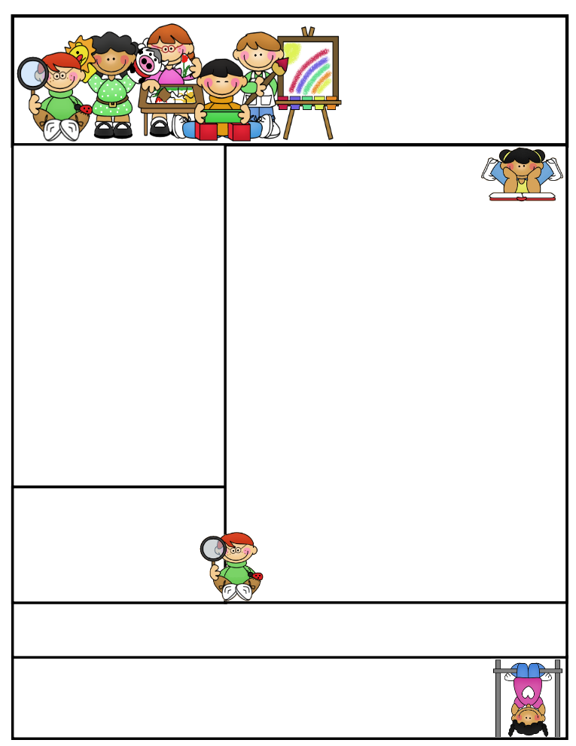

Classroom News

One of the Omegama & Friends school assembly program will be presenting their positive Superhero message to our students on Monday, October 24 from 9:00-10:00 in the small gym. Students in K4-5 are encouraged to wear a super hero costume. Their message delivers the Anti-Bullying/Character Development topics through a superhero theme. Go to [www.omegamamschools.com](http://www.omegamamschools.com) for more information.

**Our *Halloween Party will be on Monday, October 31st.*****We are collecting $2.00 from each child to cover the cost of pizza. We are in need of a bag of apples, caramel, carrots, dip, plates, and napkins. If you are willing to donate any of these items please contact me by note or email. Thank you!**

The children are to **bring their costume to school in a bag with their name marked on it**. We will not be walking to Maryhill Manor due to a time conflict. Our schedule will be the following:

**12:45 -1:00 –Early Recess**

**1:00 -1:15 – Dress in Costume**

**1:15 -2:00 – Pizza party**

**2:00 -2:45 – Grades 4K-5 Halloween Parade**

**in the theatre**

**Agenda Books**

Students are responsible for filling out their agenda book and taking it home daily to be signed. This is a great communication tool to let you know what we worked on during the day, if your child has homework to be completed, or a noteof concern.

**Literacy Tips:** Have students practice their spelling in clay, using magnetic letters, or typing them on a computer. Read with your child daily to ensure he/she is being fluent and understanding what is being read. **Reading books and/or library books should be coming home to practice reading daily.**

**Math Tips:** All students have been added to a new math program call **“front row.”** *Students*

*can access the program from home and continue where they left off.* **The classroom code is**

**3s3trg.** This is a great way to work on all skills learned thus far and **MATH FACTS!**

Math Tip:

Important Dates_

**Please remember to look at the school website for important dates and events going on in the school district.**

Remember to access **Weebly.com** to get an update on classroom activities going on and important information that your child is responsible for.

**Parent/Teacher Conferences**

***Thank you for coming to Parent/Teacher Conferences. I enjoyed meeting with all parents and look forward to seeing you throughout the year.***

Second Grade  
Newsletter

**October 24-28th, 2016**

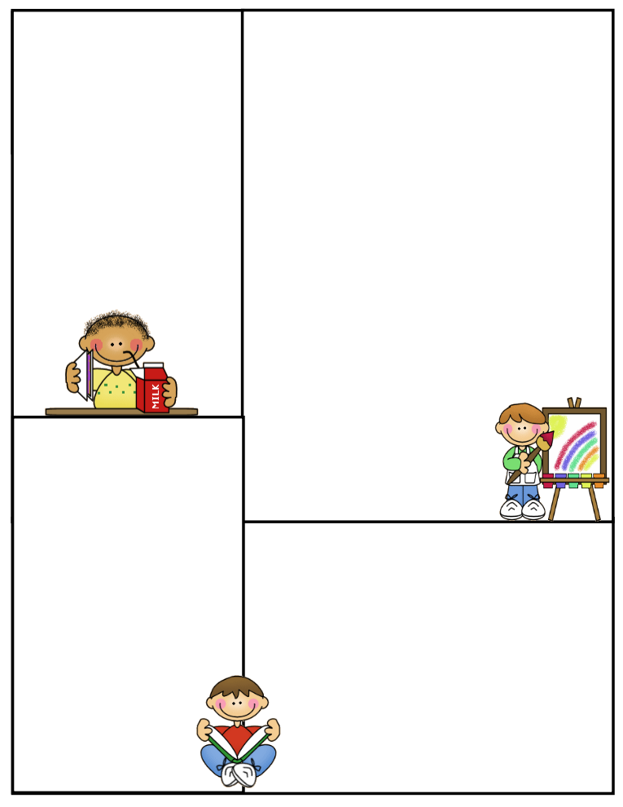

**Spelling Words to Practice:**

**Long a words**

main jay

wait pay

sail stay

tail hay

may

**Review words**

rope nose

**High Frequency words**

island special though

**Reading Vocabulary:**

**Important Information**

Please remind your child to have all the necessary materials in class daily. Reading book, agenda book, AR books, glasses (if needed), homework to be returned..etc.

No purses filled with goodies or toys in desks to be played with…etc.

**What We’re Learning**

**Reading:** Book Clubs /Babu’s Song

**Phonics/Spelling:** Long a spelled ai and ay

**Grammar:** Journal Writing, Commas, subjects, Predicates, and nouns

**Math:** Chapter 3- Making 10, Regrouping in addition

**Writing:** Mechanics

**Journal Writing**

**Science:** 5 Kingdoms and their characteristics

Plants- Planting and Growing lettuce and tomatoes

Plant parts and their jobs

Pollination / Experiment

**Social Studies:** Communities/Workers

**Computers:** Type to Learn, Accelerated Math,

Math Facts in a Flash, and Accelerated Reading &

front row

**Reading Vocabulary Words**

1. **Concern: it is important to you**
2. **Exclaimed: you cried out or shouted suddenly with strong emotion**
3. **Figure: a shape**
4. **Vendors: people who sell things**
5. **Collection: a group of objects that belong together**