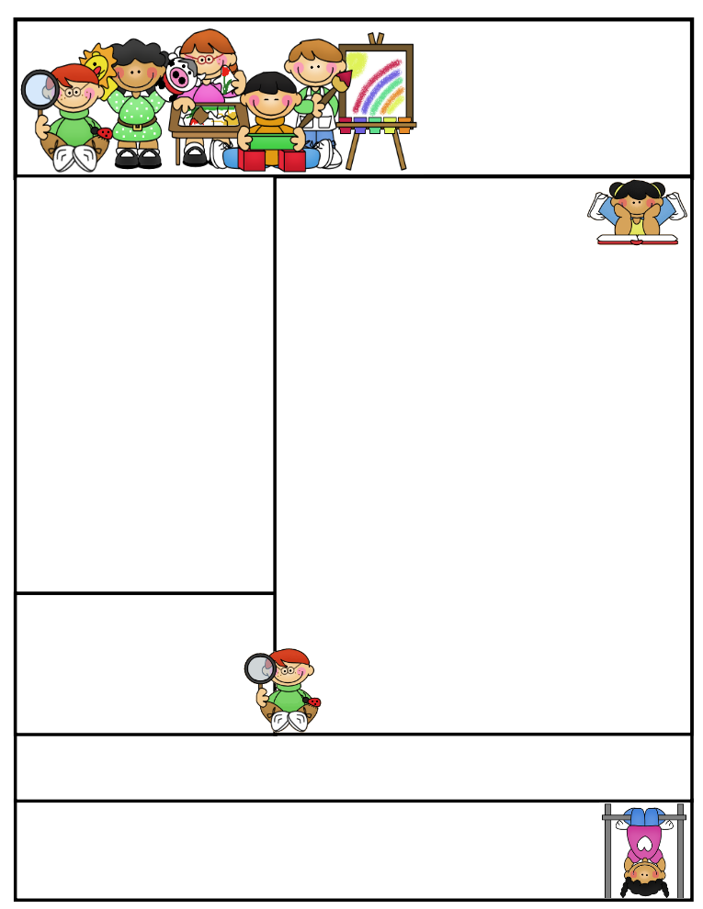

Classroom News

**Parent/Teacher Conferences**

Parent/teacher conference slips are attached to this newsletter. I tried to accommodate everyone the best I could. If your scheduled time does not work, let me know on Monday, so I can make other arrangements with you. Conferences are very important so we can discuss your child’s academic and social progress thus far, as well as, areas of strengths and improvements to be made. I am looking forward to meeting with you next Thursday between 1:00P.M. and 7:00 P.M. Conferences end at 7:00 P.M.

**Agenda Books**

Students are responsible for filling out their agenda book and taking it home daily to be signed. This is a great communication tool to let you know what we worked on during the day, if your child has homework to be completed, or a note of concern.

Second Grade  
Newsletter

**October 14th, 2016**

We have planted tomatoes, lettuce, and herbs in our Aero gardens. We will plant beans when they germinate.

**Literacy Tips:** Have students practice their spelling in clay, using magnetic letters, or typing them on a computer. Read with your child daily to ensure he/she is being fluent and understanding what is being read. **Reading books and/or library books should be coming home to practice reading daily.**

**Math Tips:** All students have been added to a new math program call **“front row.”** *Students*

*can access the program from home and continue where they left off.* **The classroom code is**

**3s3trg.** This is a great way to work on all skills learned thus far and **MATH FACTS!**

Math Tip:

Important Dates_

Please remember to look at the school website for important dates and events going on in the school district.

Remember to access **Weebly.com** to get an update on classroom activities going on and important information that your child is responsible for.

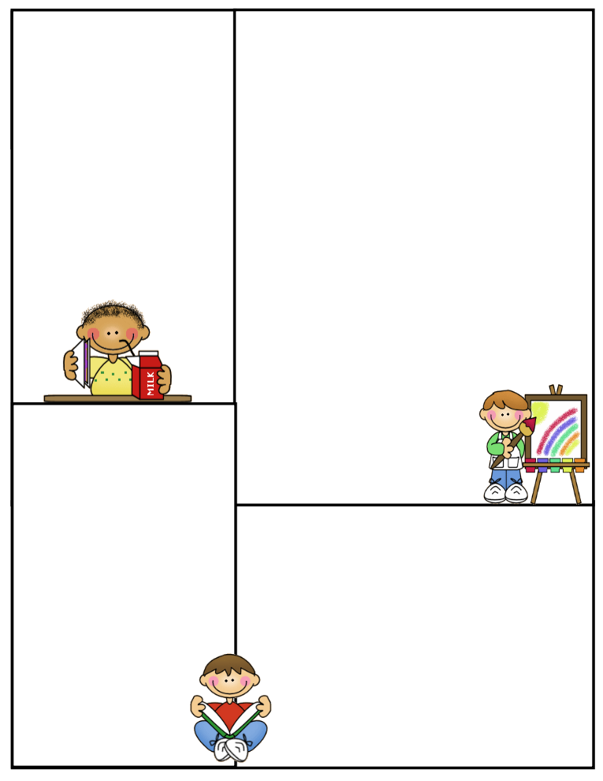

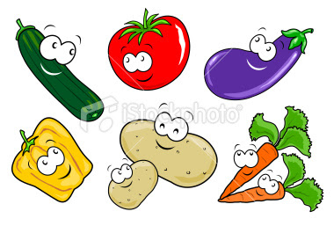

**What We’re Learning**

**Reading: Book Clubs / Accelerated Reading**

**Phonics:** Review short and long vowels

**Grammar:** Journal Writing, Commas, Subjects and Predicates

Friendly letters

**Math:** Chapter 3 Add Two-Digit Numbers with Regrouping

**Writing:** We will be working on restating a question and mechanics in writing. How to write a Friendly letter

**Journal Writing**-Sentence structure and Mechanics

**Science:** 5 Kingdoms and their characteristics

Plants- Planting and Growing lettuce and tomatoes

Plant parts and their jobs

**Social Studies:** Communities/Workers

**Computers:** Type to Learn, Accelerated Math,

Math Facts in a Flash, and Accelerated Reading &

front row

We are doing an experiment with celery, water, and food coloring to see how plants pull up water from the ground. We will be scientists and use the scientific method!

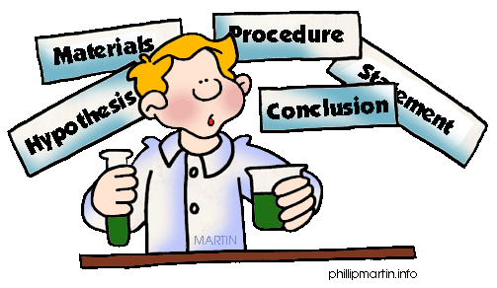

**Spelling Words to Practice:**

Review week in spelling and on vocabulary words. A spelling list with the words is included in your child’s Friday folder.

We will play Bingo, Boggle, tap–it, create sentences using words, and **read a lot**.