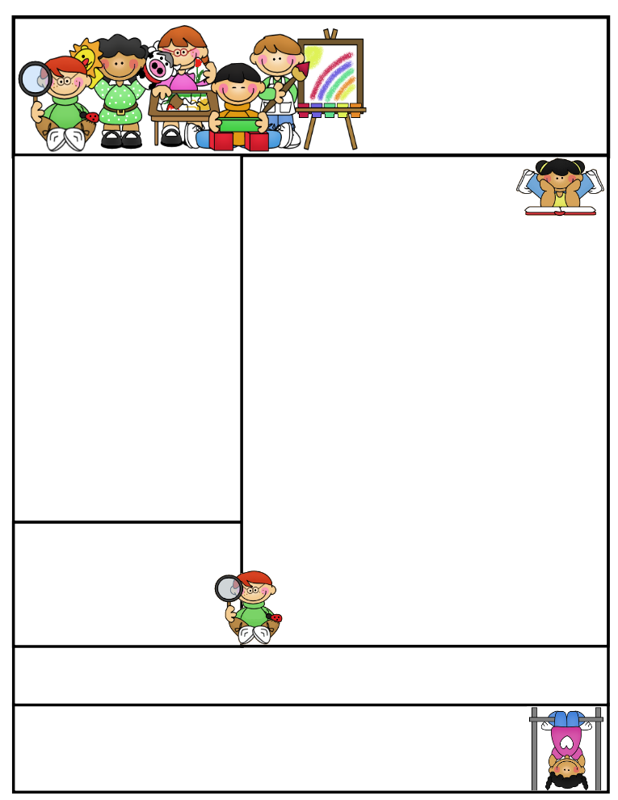

**Agenda Books**

**Students are responsible for filling out their agenda book and taking it home daily to be signed. This is a great communication tool to let you know what we worked on during the day, if your child has homework to be completed, or a note of concern**.

**Literacy Tips:** Have students practice their spelling in clay, using magnetic letters, or typing them on a computer. Read with your child daily to ensure he/she is being fluent and understanding what is being read. **Reading books and/or library books should be coming home to practice reading daily.**

**Math Tips:** All students have been added to a new math program call **“front row.”** *Students*

*can access the program from home and continue where they left off.* **The classroom code is**

**3s3trg.** This is a great way to work on all skills learned thus far and **MATH FACTS!**

Math Tip:

Important Dates_

**Please remember to look at the school website for important dates and events going on in the school district.**

Remember to access **Weebly.com** to get an update on classroom activities going on and important information that your child is responsible for.

**Parent/Teacher Conferences**

Parent/teacher conference slips will come home next week with your child’s set time to meet and discuss your child’s test scores, academic progress, social skills, and goal(s) to work towards. I look forward to meeting with all of you.

Classroom News

Please don’t forget about the Coats of Many Colors. There was an informational sheet in your child’s folder last week.

It seems that our pencil sharpeners really love to eat our pencils. The best pencils to use are **Ticonderoga**. I purchased multiple packs for the students, but we are getting low.

Rainbow House will be joining us on Tuesday, October 11th to talk about “safety.”

Just a reminder about “hand, foot, and mouth” disease that is going around and highly contagious. Remind your child to wash their hands with soap and warm water after using the bathroom, blowing their nose, coughing...etc.

**Please read with your child our new story My New HOME pgs. 110-111 My Name is Yoon on pgs. 112-137. This will help your child with fluency, word recognition, and comprehension.**

Second Grade  
Newsletter

**October 10-14, 2016**

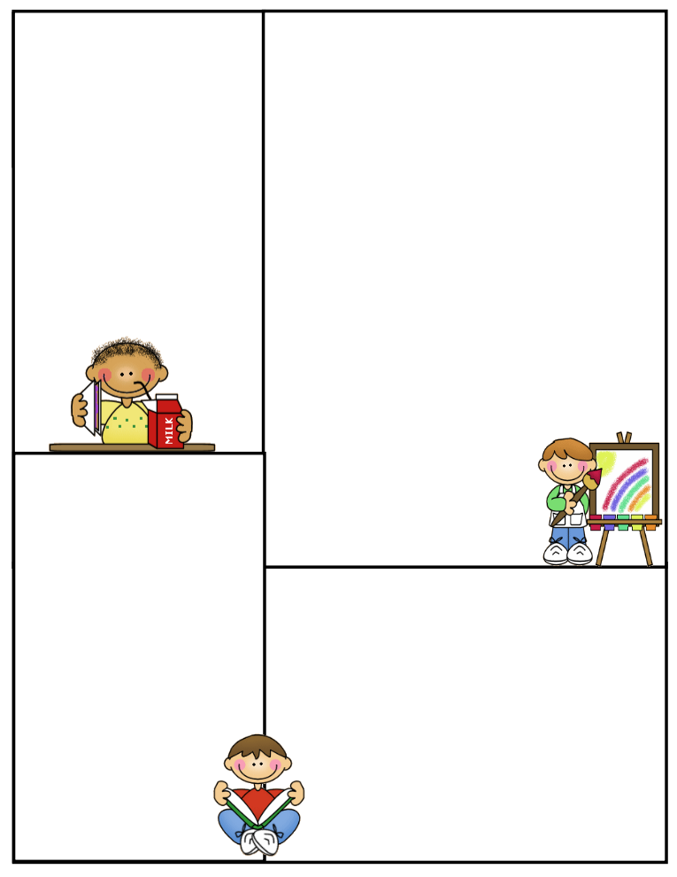

**Important Information**

**A big “Thank you” to all who donated nonperishable goods for the food pantry.**

**Second grade won the “box top” award for the month of September. We were surprised with ice cream sandwiches and fruit popsicles. Thank you PTO for being so kind to us! We appreciate all your extra efforts and time put forth to make our school a wonderful place to be a part of.**

**What We’re Learning**

**Reading: Book Clubs / My Name is Yoon**

**Phonics:** **short /o/ and Long/o/ words**

**Grammar:** Journal Writing, Commas and Predicates

Friendly letters

**Math:** Chapter 2-Number Patterns, odds, evens, and + and – within 100, multistep problem solving, and arrays.

**Writing:** We will be working on restating a question and mechanics in writing. How to write a Friendly letter

**Journal Writing**-Sentence structure and Mechanics

**Science:** 5 Kingdoms and their characteristics

Plants- Planting and Growing lettuce and tomatoes

Plant parts and their jobs

**Social Studies:** Communities/Workers

**Computers:** Type to Learn, Accelerated Math,

Math Facts in a Flash, and Accelerated Reading &

front row

**Vocabulary Words**

**Cuddle: to hold close in one’s arms**

**Favorite: a person or thing liked best**

**Patient: being able to put up with problems or delays without getting upset**

**Practiced: did something again and again until it was done well**

**Settled: mad a home in a place**

**Wrinkled: made a fold, ridge, or line in a smooth surface**

**Spelling Words to Practice:**

**Short /o/ and Long /o/ words**

pot box fox dog lock

rope poke nose home cone

**Review words:**

line side

**High Frequency words**

world country America

**Reading Vocabulary:**