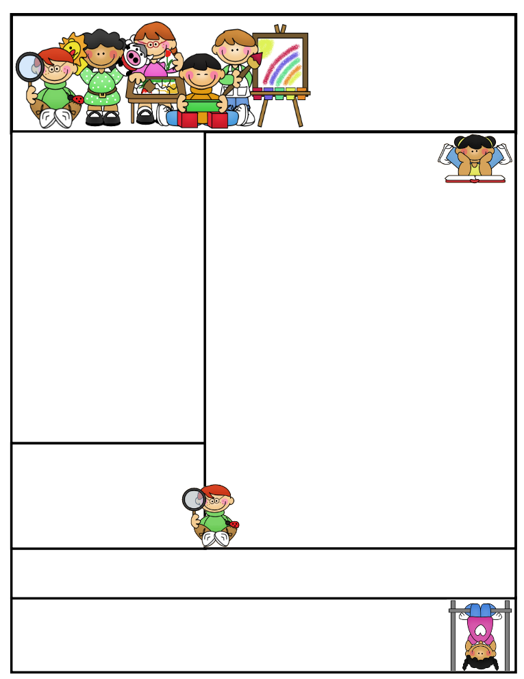

Important Dates

**PALS testing will start the week of September 26th. It is a state assessment that will give me a benchmark to use for developing a program specifically for your child to provide additional help to improve on the skills he/she is lacking. There is a Fall, Winter, and Spring assessment given for comparison and tracking growth or losses made throughout the year. It will be very important that your child is well rested, given a healthy breakfast, and in school when testing begins. There is a window in which the test needs to be administered and the data sent into the state.**

Classroom News

**A new Spelling word list was sent home on Tuesday with your child. We will be working on short /e/, /o/, and /u/ words. Please start practicing now ☺ Words are on the back side of the newsletter.**

**We will still be working towards developing our daily routine and expectations in the classroom, hallway, bathroom, cafeteria, playground, and on the bus. Modeling the appropriate behavior used in the various areas is very important for the students to learn. “Good Citizenship” is part of our Social Studies Curriculum and PBIS.**

**Our story for the week is Mr. Putter and Tabby Pour the Tea. Please read with your child to ensure good reading techniques and comprehension skills are being used.**

**Fundraisers are due on Tuesday, September 27th. All information was sent home on Tuesday with your child. Students are doing a great job selling items!**

Second Grade  
Newsletter

**September 16, 2016**

**Literacy Tips:** Reading with your child daily will increase their word recognition, fluency, comprehension, and love for reading**. “Good Fit” books allow students to read at their own level and interest.** The students may check books out of my leveled book bins, as well.

**Math Tips:** Students who practice and master their addition and subtraction facts will be more successful in math. Facts are the basic building blocks needed for each consecutive lesson taught. Those who practice 10 minutes a night will find that they will spend less time on math assignments and making corrections on their papers.

Math Tip:

**Students are responsible for filling out their agenda book and taking it home daily to be signed. This is a great communication tool to let you know what we worked on during the day, if your child has homework to be completed, or a note of concern.**

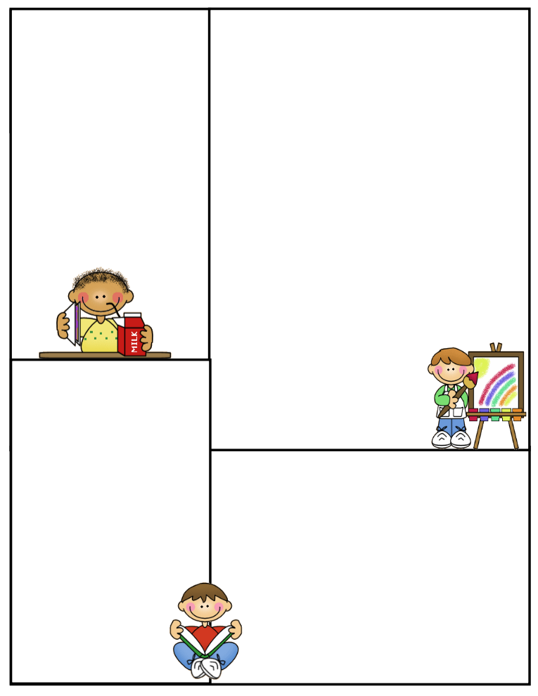

**What We’re Learning**

**Reading:** Mr. Putter and Tabby Pour the Tea/ Daily 5 Chapter books

**Phonics:** short /e/, /o/, /u/ sounds

**Grammar:** What is a sentence? Types of sentences

**Math:** We are working on addition in Math. Students will be responsible for all math vocabulary words/definitions on their chapter tests. Each student has a set of cards in their book. Tests will include story problems.

**Writing:** We will be working on types of sentences and restating questions.

Journal Writing-Sentence structure and Mechanics

**Science:** Life Cycle of a Butterfly / Activities

**Social Studies:** Citizenship, PBIS

**Computers:** Type to Learn,

Accelerated Math, Math Facts in a Flash, and Accelerated Reading

**Reading Vocabulary**

**delighted:** very pleased or happy

**enjoyed:** got joy or pleasure; was happy with

**share:** to give some of what one person has to someone else

**thinning:** becoming thin; decreasing in number

**wonderful**: very good

Other Information Here

***All students need to practice their addition and subtraction facts.* Flashcards are available at the Dollar Store or you could use index cards to write the problems on.**

**We are going into the computer lab on Thursday’s from 9:30-10:25 to work on Type to Learn and Math Facts in a Flash. Students who have late work from the previous day will have to complete before going onto the computer.**

**Spelling Words to Practice:**

**Short /e/, /o/, and /u/**

**went tell pet**

**job not fog**

**tug tub hut**

**Review words:**

**fix has**

**High Frequency words**

**move year another**

**Reading Vocabulary:**