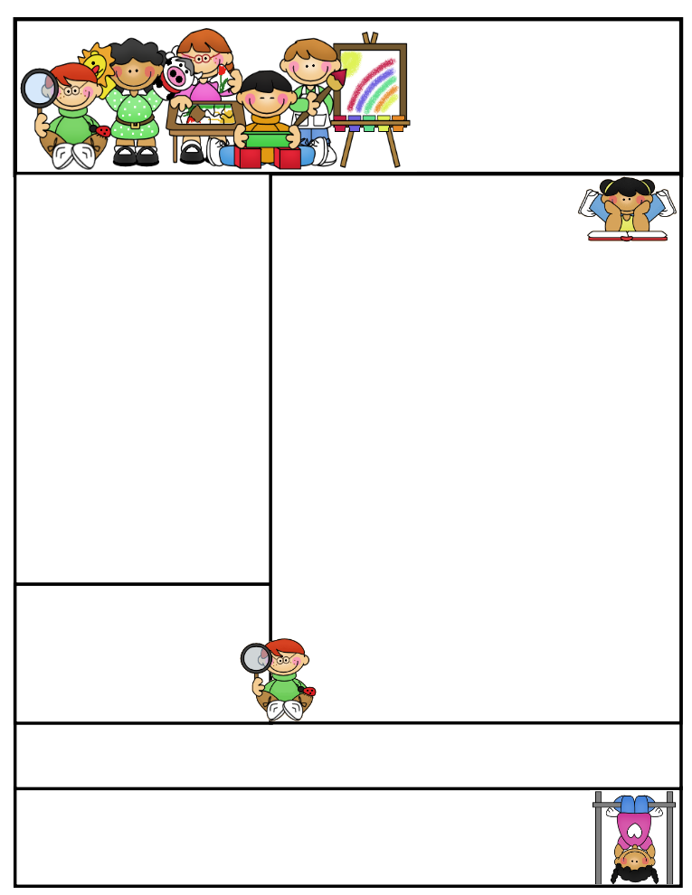

Important DatesSpelling Test on short /a/ and /i/ words on Wednesday, 9-14-16.

Reading Test on David’s New Friends on Wednesday, 9-14-16 due to Star Testing this week. We still have skills to cover before taking the test.

Book Order Form due date will be Friday, September 16th. Please make checks payable to Scholastic.

**Inside your child’s Friday folder are their test results for Star Reading and Math.**

We will also be PALS testing in the upcoming weeks.

Second Grade  
Newsletter

**September 12, 2016**

**Literacy Tips:** Reading with your child daily will increase their word recognition, fluency, comprehension, and love for reading. “Good Fit” books allow students to read at their own level.

**Math Tips:** Students who practice and master their addition and subtraction facts will be more successful in math. Facts are the basic building blocks needed for each consecutive lesson taught. Those who practice 10 minutes a night will find that they will spend less time on math assignments and making corrections on their papers. ( Look on the other side)

Math Tip:

Students will start filling out their **agenda book** and **taking it home daily to be signed.** They will earn a ticket for our class store. I do send notes home in the agenda books, so please ask your child for it.

Classroom News

This week we will still be working towards developing our daily routine and expectations in the classroom, hallway, bathroom, cafeteria, playground, and on the bus. Modeling the appropriate behavior used in the various areas is very important for the students to learn. “Good Citizenship” is part of our Social Studies Curriculum and PBIS.

Students need to practice reading their weekly story at home, as well as, in school. Please read with your child, so they are practicing the various skills good readers use. Ask your child what some of the strategies we are talking about in class.

***All students need to practice their addition and subtraction facts.*** Flashcards are available at the Dollar Store.

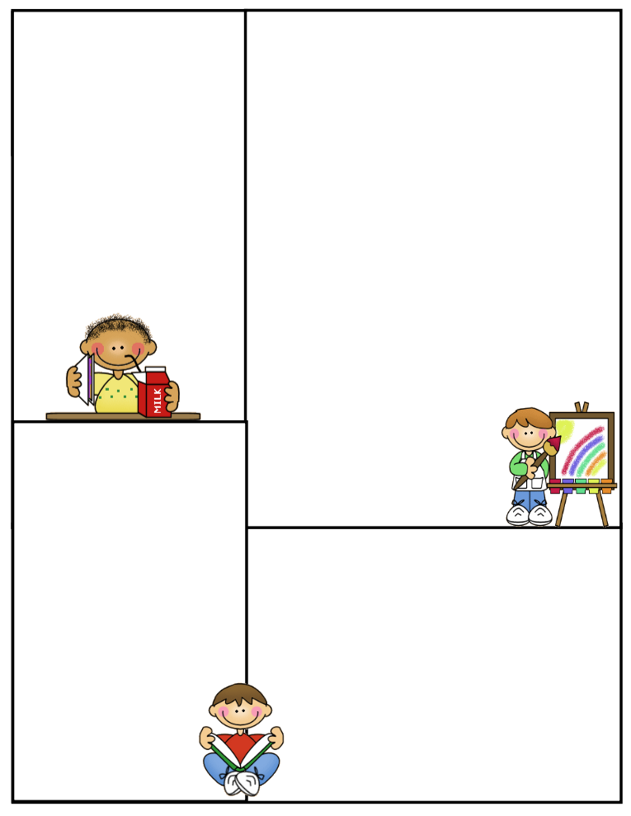

**What We’re Learning**

**Reading:** David’s New Friends

**Phonics:** short /a/, /i/, /e/ sounds Consonant blends

**Grammar:** What is a sentence? Types of sentences

**Math:** We are working on addition in Math. Students will be responsible for all math vocabulary words/definitions on their chapter tests. Each student has a set of cards in their book. Tests will include story problems.

**Writing:** We will be working on types of sentences and restating questions.

Journal Writing-Sentence structure and Mechanics

**Science:** Life Cycle of a Butterfly / Activities

**Social Studies:** Citizenship, PBIS

**Reading Vocabulary**

**groan:** to make an unhappy sound

**different:** not the same

**whisper:** speaking quietly

**carefully:** with care

**excited:** made very happy about something

Other Information Here

*Reminder Book Orders are due Sept. 17th

Please remember all students need to go outside in the morning and are not be in the hallways or classrooms. Thank you for your help!!

Have a super weekend!!!

**Spelling Words to Practice:**

**Short a Short i**

**has will**

**wag him**

**sat if**

**bad six**

**had fix**

**can hit**

**High Frequency words**

**even blue study**

**Reading Vocabulary:**