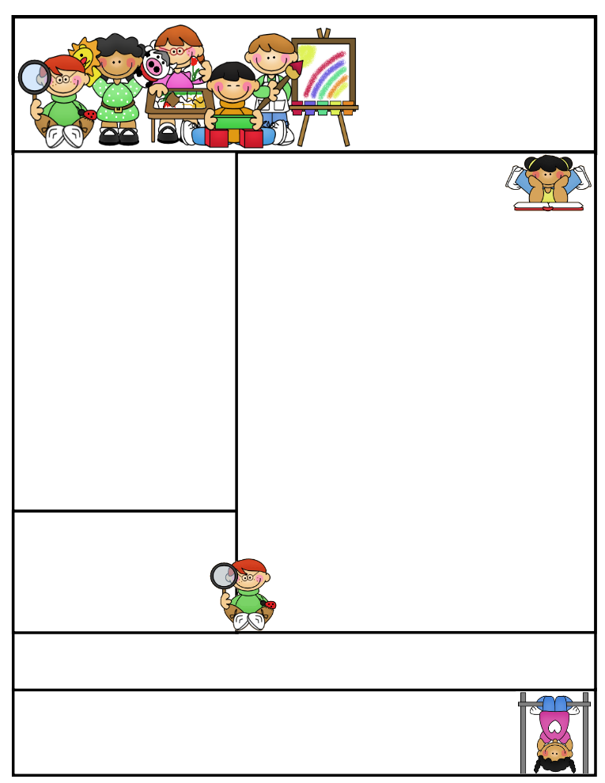

Important DatesSeptember 5th-Labor Day-No School

Spelling Test on short a and i words on Fri., Sept. 9th

Reading Test on David’s New Friends on Fri., Sept. 9th

Book Order Form due date will be Friday, September 16th.

Star Testing in Reading and Math will be next week.

**Literacy Tips:** Reading with your child daily will increase their word recognition, fluency, comprehension, and love for reading. “Good Fit” books allow students to read at their own level.

**Math Tips:** Students who practice and master their addition and subtraction facts will be more successful in math. Facts are the basic building blocks needed for each consecutive lesson taught. Those who practice 10 minutes a night will find that they will spend less time on math assignments and making corrections on their papers.

Math Tip:

**Congratulations** to **Kyle Kay** for winning the ***“Classroom Supply Cake”*** for our class. Our PTO is wonderful!

Second Grade  
Newsletter

**September 2, 2016**

Classroom News

Welcome back to a new, exciting school year. Two days in and many to go! This is a great group of students and I am so excited to be their teacher!

This week we will be working towards developing our daily routine and expectations. Students will be responsible to read David’s New Friends in their reading book. Our grammar and spelling words are integrated into our reading curriculum.

Please practice with your child, so he/she is prepared for their tests.

All students will be taking daily timed tests and practicing their facts during daily 5 in math.

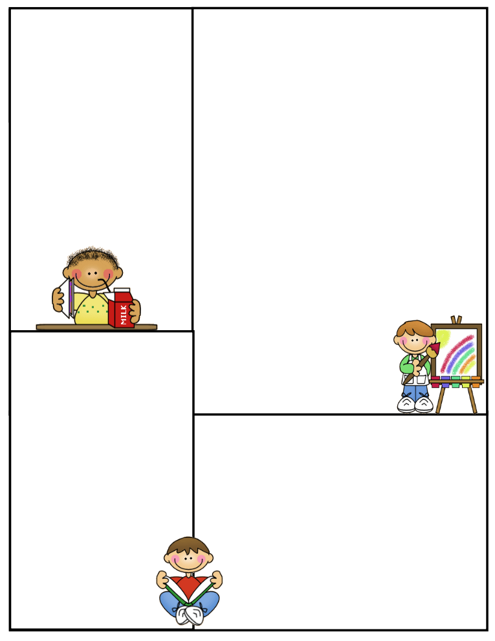

What We’re Learning

**Reading:** David’s New Friends

**Phonics:** short /a/, /i/, /e/ sounds

Consonant blends

**Grammar:** What is a sentence? Types of sentences

**Math:** We are working on addition in Math. Students will be responsible for all math vocabulary words/definitions on their chapter tests. Each student has a set of cards in their book. Tests will include story problems.

**Writing:** We will be working on types of sentences and restating questions.

Journal Writing

**Science:**

Life Cycle of a Butterfly / Activities

**Social Studies:**

Citizenship, PBIS

**Reading Vocabulary**

**groan:** to make an unhappy sound

**different:** not the same

**whisper:** speaking quietly

**carefully:** with care

**excited:** made very happy about something

Other Information Here

Please remember all students need to go outside in the morning not be in the hallways or classrooms. Thank you for your help!!

Have a great weekend!!!

**Spelling Words to Practice:**

**Short a short i**

**has will**

**wag him**

**sat if**

**bad six**

**had fix**

**can hit**

**High Frequency words**

**even blue study**

**Reading Vocabulary:**