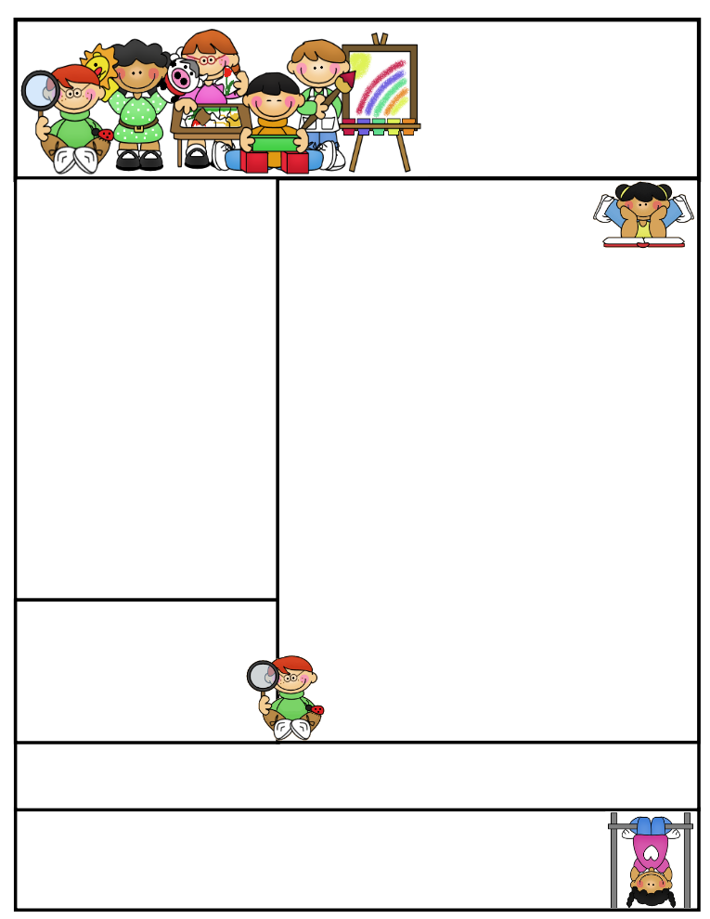

Classroom News

**We are currently doing a few science projects in class using the Scientific Method. One experiment involves growing bean plants in soil, sand, and plain water.**

**We also have 2 hydroponics gardens in which we are growing carrots,** red **and yellow cherry tomato plants,** and herbs: **Parsley,** Cilantro, and Dill. I will order lettuce seeds to make our healthy garden complete. We will have salad parties throughout the year which correlates with our science and health curriculums.

The students are also making their own hand plant pollinators. They create and present their invention to the class. Fun stuff!!!

All parents should have received an email about a photo release form from Bill Harris. He is coming to Niagara to present and do hands on projects with the students on magnetism. Without your consent, your child will not be able to be in the videos being taken as they complete their tasks. Please check your email, so we know who can participate. He has worked with the 7th and 8th graders in Nicole Anderson’s Science classes.

**Agenda Books**

Students are responsible for filling out their agenda book and taking it home daily to be signed. This is a great communication tool to let you know what we worked on during the day, if your child has homework to be completed, or a noteof concern.

**Literacy Tips:** Have students practice their spelling in clay, using magnetic letters, or typing them on a computer. Read with your child daily to ensure he/she is being fluent and understanding what is being read. **Reading books and/or library books should be coming home to practice reading daily.**

**Math Tips:** All students have been added to a new math program call **“front row.”** *Students*

*can access the program from home and continue where they left off.* **The classroom code is**

**3s3trg.** This is a great way to work on all skills learned thus far and **MATH FACTS!**

Math Tip:

Important Dates_

**Please remember to look at the school website for important dates and events going on in the school district.**

Remember to access **Weebly.com** to get an update on classroom activities going on and important information that your child is responsible for.

**Thank you to everyone who donated to our Halloween Party.***A special thank you to Karen Holt who picked up our pizzas for us!!*

Second Grade  
Newsletter

**November 4, 2016**

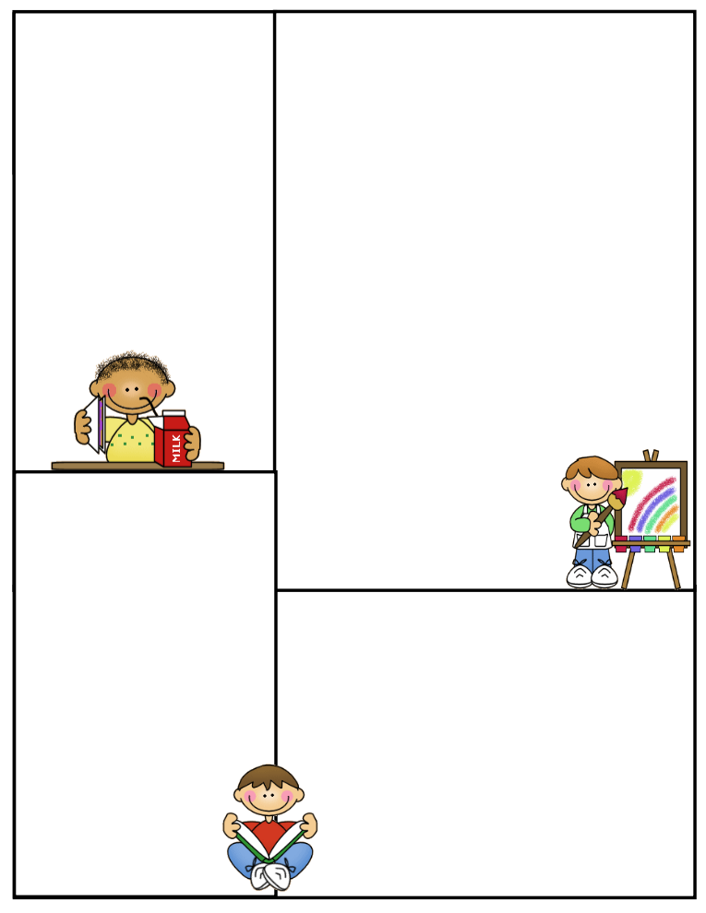

**Spelling Words to Practice:**

**Long i words**

**i igh ie y mind light lie cry**

**wild sight tie dry**

**high try**

**Review words**

**baby queen**

**High Frequency words**

**different other number**

**Reading Vocabulary:**

**Important Information**

Please remind your child to have all the necessary materials in class daily. Reading book, agenda book, AR books, glasses (if needed), homework to be returned..etc.

No purses filled with goodies or toys in desks to be played with…etc.

**What We’re Learning**

**Reading:** Book Clubs / A Tall pgs.240-241 242-243

**Phonics/Spelling Long I**

**Grammar:** Commas, subjects, Predicates, and nouns

**Math:** Chapter 4 Subtraction with regrouping

**Writing:** Mechanics

**Journal Writing**

**Science:**

Plants- Planting and Growing lettuce and tomatoes

Plant parts and their jobs

Pollination / Experiment

**Social Studies:** Communities/Workers **-**Importance

**The meaning of Veteran’s Day / Government**

**Computers:** Type to Learn, Accelerated Math,

Math Facts in a Flash, and Accelerated Reading &

front row

**Reading Vocabulary Words**

1. **Independence:** freedom
2. **Landmark:** a building, place, or thing that people know well
3. **Government:** the people who run a country or a state
4. **State:** having to do with a specific part of a country
5. **Symbol:** something that stands for something else