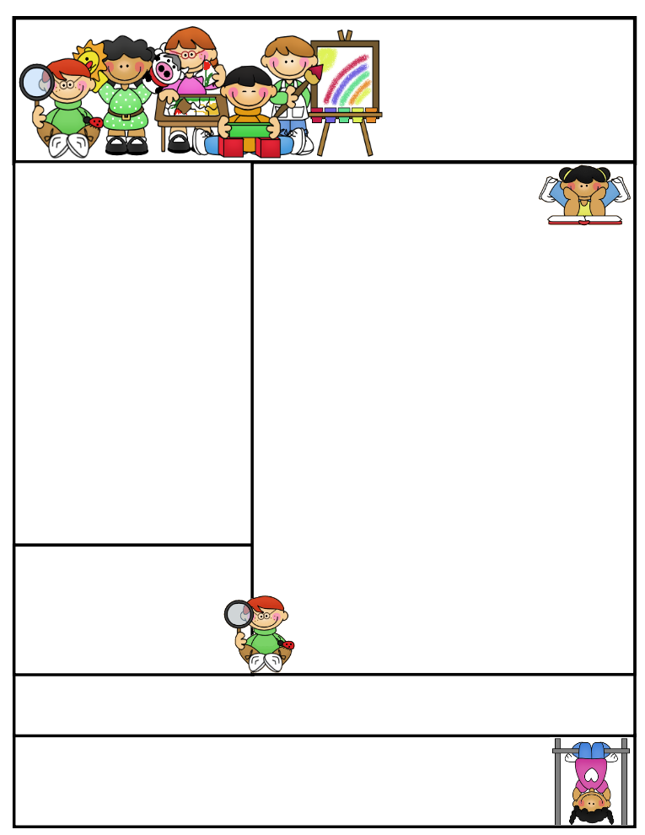

**Literacy Tips:** Have students **practice their spelling** in clay, using magnetic letters, or typing them on a computer. Read with your child daily to ensure he/she is being fluent and understanding what is being read. **Reading books and/or library books should be coming home to practice reading daily.**

**Math Tips:** Please practice **addition** and **subtraction** flashcards **daily.** Continue to work on **front row from home. I receive updates on the improvements the students are making. The classroom code is 3s3trg. I have seen improvement in many students!!**

Math Tip:

Second Grade  
Newsletter

**October 31st –Nov.4, 2016**

Classroom News

**Our *Halloween Party will be on Monday, October 31st.*****We are collecting $2.00 from each child to cover the cost of pizza. We are in need carrots, dip, and plates. If you are willing to donate any of these items, please contact me by note or email. Thank you!**

The children are to bring their costume to school in a bag with their name marked on it. **We will be walking to Maryhill Manor.**

**Our schedule will be the following:**

**12:00- Get into costumes**

**12:15-1:00 Walking to Maryhill Manor- Students need to bring a plastic bag in case candy is given.**

**1:15 -2:00 – Pizza party**

**2:00 -2:30– Grades 4K-5 Halloween Parade**

**in the theatre**

**2:35-2:55- Classroom fun pages**

Today we had Ann Bartels present on different types of owls and the prey they eat. We dissected owl pellets and tried to figure out what was in the owl pellet and match each bone with its description on the owl pellet bone page.

**Agenda Books**

**Students are responsible for filling out their agenda book and taking it home daily to be signed. This is a great communication tool to let you know what we worked on during the day, if your child has homework to be completed, or a note of concern.**

Important Dates_

**Please remember to look at the school website for important dates and events going on in the school district.**

Remember to access **Weebly.com** to get an update on classroom activities going on and important information that your child is responsible for.

All students were given an updated letter on our Halloween Party Thursday. Some left them on their desks, so the new schedule is under the category classroom News.

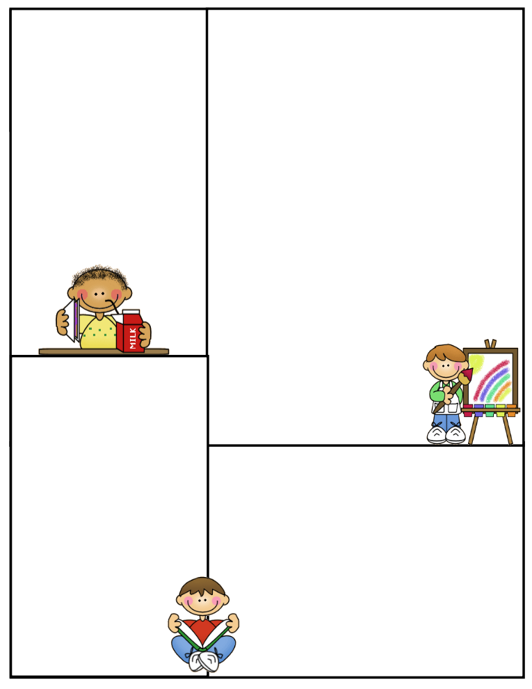

**Science Vocabulary Words**

Photosynthesis pollination

Roots Chloroplasts

Chlorophyll nutrients

Stem water

Leaves carbon dioxide

Chloroplasts oxygen

Chlorophyll sunlight

sugar

Students will have to know the basic plant parts and their job.

We will practice what occurs during photosynthesis and then the students will be tested.

**Spelling Words to Practice:**

**Long e words spelled e, ea, ee, y**

**we eat seek baby**

**he mean queen pony**

**leaf need**

**Review words**

**stay train**

**High Frequency words**

**word against morning**

**Reading Vocabulary:**

**Important Information**

Please remind your child to have all the necessary materials in class daily. Reading book, agenda book, AR books, glasses (if needed), homework to be returned...etc.

No purses filled with goodies or toys in desks to be played with…etc.

**What We’re Learning**

**Reading:** Book Clubs, AR, Star Reading & Math Test

**Phonics/Spelling: Long e words: e, ea, ee, y words**

**Grammar:** Commas, subjects, Predicates, and nouns, mechanics of writing

**Math:** Chapter 3- Making 10, Regrouping in addition

**Writing:** Mechanics

**Journal Writing: What you want to be when you grow up**

**Science:**

Plants- Planting and Growing lettuce and tomatoes

Plant parts and their jobs

Pollination / Experiment

**Social Studies:** Communities/Workers**/**Jobs

**Computers:** Type to Learn, Accelerated Math,

Math Facts in a Flash, and Accelerated Reading &

front row