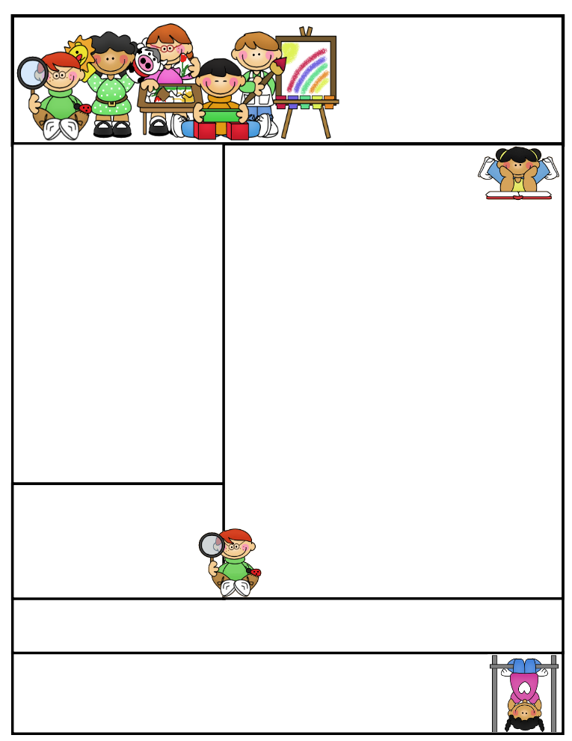

**Agenda Books**

All agenda books need to be filled out, brought home, initialed, and sent back to school.

**Grandparents Program will be on May 31st at 1:00P.M.**

**Second Grade  
Newsletter**

**May 5, 2017**

Classroom News

I am very proud of the students on how well they all did on their PALS Testing. The growth and maturity from the beginning of the year until now is amazing. A report will be included in my end of the year packet.

Next week, we will be testing in Star Reading and Math. These reports will be included in the packet, as well. I am hoping to see growth in all students, so make sure your child gets plenty of rest and eats a healthy breakfast. I will test in Reading on Monday morning and Math on Thursday morning in the computer lab.

We will candle the eggs on Tuesday morning to see if our eggs are in good shape for hatching. The eggs that did not make it will be separated out and disposed of. The students know that it is unlikely that all the eggs will hatch, but are very positive that all of them will. ☺ We are still being very patient and good babysitters.

Troy is still hanging around and enjoying his life in second grade. He is very easy to care for and always gets his work done. He always has a watchful eye on the kids.

Our salad party was a huge success! This class enjoys lettuce and all the toppings to go with. It is wonderful to see so many students taking pride in their Aero Garden plants. Lettuce and cherry tomatoes are always better when you grow them yourself! Thank you to Lynn Dunkes for donating to our party.

Since the students worked so hard this week on their testing, they were treated to a movie this afternoon. I believe they all deserved to be rewarded for their hard work and effort.

I can’t wait to see all the beautiful girls at the Father/Daughter Dance this weekend! Have a great time!

**Important Reminders**

**Badger Summer Camp will include *FREE breakfast* and *FREE lunch*. *Everyone* is WELCOME to attend. The camp will run the week of July 24th-27th and July 31st- August 3rd. Breakfast is at 7:30 and camp starts at 8:00A.M. through 12:00P.M. Lunch will then be provided. Informational sheet in folder last week.**

[](http://www.bing.com/images/search?q=sun+images&id=0B8F48D11D6C3555BC82A602BF5F5B6E54506B3F&FORM=IQFRBA) [](http://www.bing.com/images/search?q=sun+images&id=0B8F48D11D6C3555BC82A602BF5F5B6E54506B3F&FORM=IQFRBA)

Let the warm weather begin and stick around! Students may bring in water bottles to have in class. A happy student is a hydrated student. Only plain water may be in the bottle.

**Literacy Tips: Have students practice their spelling in clay, using magnetic letters, or typing them on a computer. Read with your child daily to ensure he/she is being fluent and understanding what is being read. Reading books and/or library books should be coming home to practice reading daily.**

**Math Tips: All students have been added to a new math program call “front row.” *Students***

***can access the program from home and continue where they left off.* The classroom code is**

**3s3trg. This is a great way to work on all skills learned thus far and MATH FACTS!**

**All students need to work on addition and subtraction facts. Let’s go second graders!!!**

Math Tip:

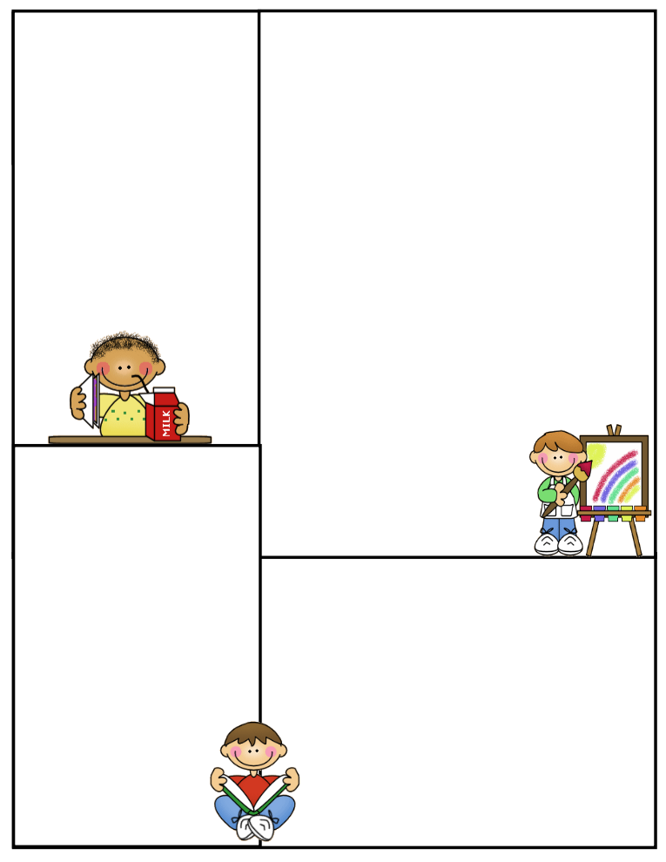

**Spelling words: open syllables**

**no noble bacon relate**

**male female return lion**

**baby basic**

**Review:**

**little middle**

**Challenge: High Frequency Words**

**door order remember**

**Robust Vocabulary:**

**defend encounter locate**

**positive react**

**Vocabulary Words:**

**glanced:** to look at something very quickly

**noble**: shows qualities of high moral

**gleamed:** shone or glowed

**promised:** to do something you said you would definitely do it

**wiggled:** moved from side to side

**What We’re Learning**

**Reading: Book Clubs Leveled reader books – Students will test their comprehension by taking an AR Test after their book is finished**

**Reading Book: My Home in Alaska pgs. 288-289**

**Nutik, the Wolf Pup pgs. 290-309 AR TEST**

**(**[**www.reading.ecb.org**](http://www.reading.ecb.org)**) – go into the book and play games that practice reading strategies**

**Spelling:**

**Grammar: adjectives & adjectives that compare**

**Daily warm-up…reading comprehension**

**Math: More Geometry and Review Packets on all the skills taught this year. Multiplication will be worked on as well.**

**Writing: Mechanics-sentence structure, & spelling**

**Science: Properties of different types of objects**

**Social Studies: Economics Goods/Services/Needs/Wants**

**(**[**www.kids.nationalgeographic.com**](http://www.kids.nationalgeographic.com)**) – learn about geography and fascinating animals**

**Computers: Type to Learn, Fact Dash, Front Row**

**Word study, ELA- Reading/Comprehension**

**Sight word bingo**

**(**[**www.abcya.com/dolch_sight_word_bingo.htm**](http://www.abcya.com/dolch_sight_word_bingo.htm)**)**

**Here are some sites the students can access to get extra practice in various areas.**

[**http://www.abcya.com/measuring.htm**](http://www.abcya.com/measuring.htm)

[**http://bigiqkids.comMeaurementGame.shtml**](http://bigiqkids.comMeaurementGame.shtml)

[**https://www.shepardsoftware.com/mathgames/menus/measurement.htm**](https://www.shepardsoftware.com/mathgames/menus/measurement.htm)

**Have a great weekend!**

**Terri**

**Ask your child what he/she learned from Ann Bartels today. She is amazing!**