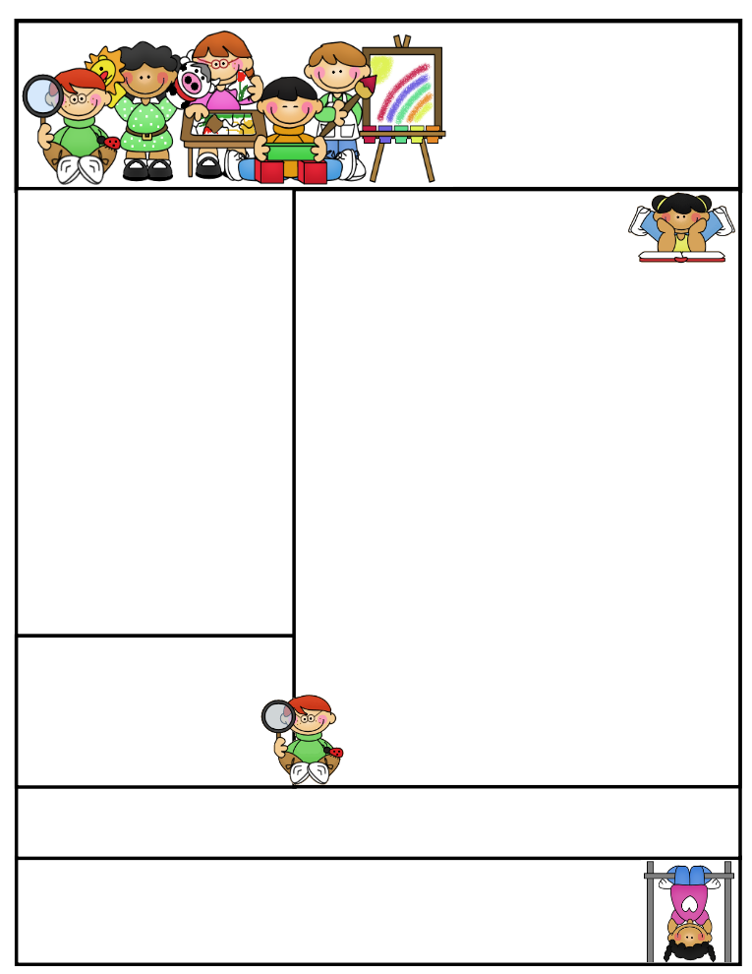

Classroom News

Students need to be reading every night for Accelerated Reading. A chapter book should be coming home daily, unless your child has an AR book he/she is reading already at home. All students should be reading at least 30 minutes. **Here are some statistics on reading:**

**75% of what children learn in their lifetime is learned by age two.**

**15 minutes of reading with your children each day can expose them to 1 million written words in a year.**

**6-8 year olds’ comprehension had been shown to significantly improve when asked to retell a story that has been told to them.**

**Books contain many words that children are unlikely to encounter frequently in spoken language. Children’s books actually contain 50% more rare words than primetime television.**

**Agenda Books**

All agenda books need to be filled out, brought home, initialed, and sent back to school.

**Second Grade  
Newsletter**

**May 26, 2017**

**Important Reminders**

**Badger Summer Camp will include *FREE breakfast* and *FREE lunch*. *Everyone* is WELCOME to attend. The camp will run the week of July 24th-27th and July 31st- August 3rd. Breakfast is at 7:30 and camp starts at 8:00A.M. through 12:00P.M. Lunch will then be provided. Informational sheet in folder last week.**

[](http://www.bing.com/images/search?q=sun+images&id=0B8F48D11D6C3555BC82A602BF5F5B6E54506B3F&FORM=IQFRBA) [](http://www.bing.com/images/search?q=sun+images&id=0B8F48D11D6C3555BC82A602BF5F5B6E54506B3F&FORM=IQFRBA)

Let the warm weather begin and stick around! Students may bring in water bottles to have in class. Please send in a note to verify. A happy student is a hydrated student. Only plain water may be in the bottle.

**Literacy Tips: Have students practice their spelling in clay, using magnetic letters, or typing them on a computer. Read with your child daily to ensure he/she is being fluent and understanding what is being read. Reading books and/or library books should be coming home to practice reading daily.**

**Math Tips: All students have been added to a new math program call “front row.” *Students***

***can access the program from home and continue where they left off.* The classroom code is**

**3s3trg. This is a great way to work on all skills learned thus far and MATH FACTS!**

**All students need to work on addition and subtraction facts. Let’s go second graders!!!**

Math Tip:

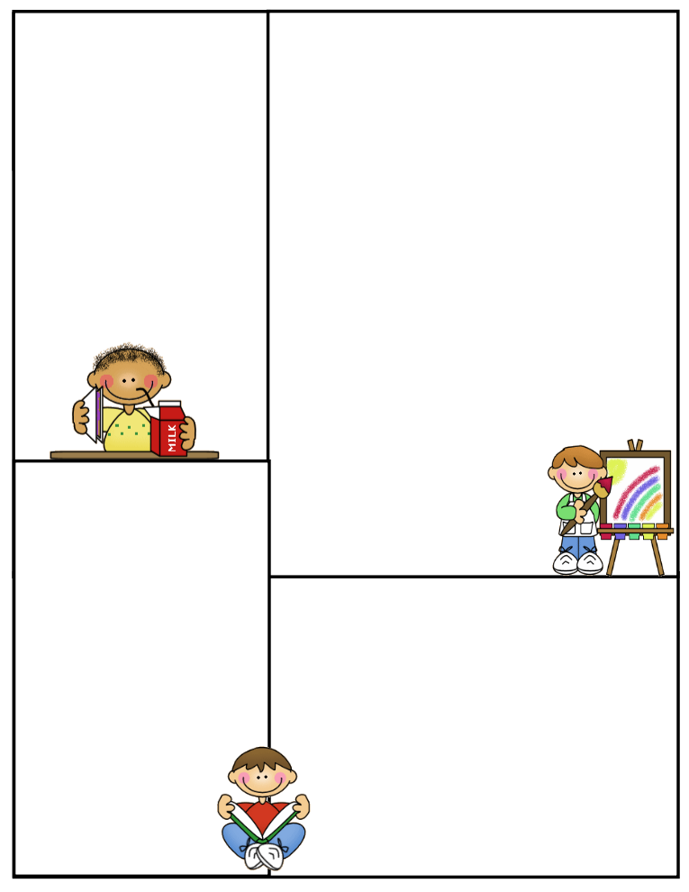

**Spelling words:**

**Commonly misspelled words in second grade**

**would with**

**whole when**

**were went**

**want very**

**upon outside**

**people sometimes**

**thought once**

**night**

**Front Row**

**Word Study- ELA**

**All students are working at their own pace on phonics and comprehension. This program is a wonderful tool to use at home for improvement and becoming a successful reader. It creates stamina and allows for extra enrichment and adaptive practices. I highly recommend the continuation of this program over the summer.**

**What We’re Learning**

**Reading: Book Clubs Leveled reader books – Students will test their comprehension by taking an AR Test after their book is finished. Also, students are writing summaries on each chapter, as well.**

**(**[**www.reading.ecb.org**](http://www.reading.ecb.org)**) – go into the book and play games that practice reading strategies**

**Spelling: Test on Friday-More most common misspelled words in second grade**

**Grammar: Review skills learned this year**

**Math: Review Packets on all the skills taught this year. Inquiry based math - Fractions**

**Writing: Mechanics-sentence structure, & spelling- Journal writing**

**Science: Properties of different types of objects**

**Social Studies: Economics- Creating a Business- Group work**

**(**[**www.kids.nationalgeographic.com**](http://www.kids.nationalgeographic.com)**) – learn about geography and fascinating animals**

**Computers: Type to Learn, Fact Dash, Front Row**

**Word study, ELA- Reading/Comprehension**

**Sight word bingo**

**(**[**www.abcya.com/dolch_sight_word_bingo.htm**](http://www.abcya.com/dolch_sight_word_bingo.htm)**)**

**Here are some sites the students can access to get extra practice in various areas.**

[**http://www.abcya.com/measuring.htm**](http://www.abcya.com/measuring.htm)

[**http://bigiqkids.comMeaurementGame.shtml**](http://bigiqkids.comMeaurementGame.shtml)

[**https://www.shepardsoftware.com/mathgames/menus/measurement.htm**](https://www.shepardsoftware.com/mathgames/menus/measurement.htm)

**Have a great weekend!**

**Terri**