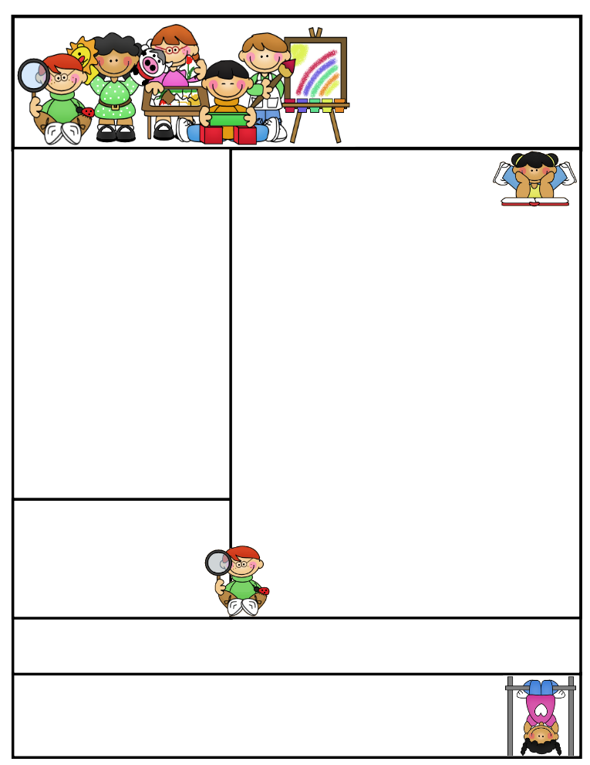

Classroom News

Students need to be reading every night for Accelerated Reading. A chapter book should be coming home daily, unless your child has an AR book he/she is reading already at home. All students should be reading at least 30 minutes.

Our chicks didn’t turn out so well. We had multiple eggs hatch, but most didn’t make it. On Tuesday, we had 5 living chicks, but on Wednesday morning 3 were dead. We are not sure why, but it’s nature’s way of telling us they were sick. (BOO HOOOOO!) We have two living and are enjoying their peeps.

**Parents’ Night Out**

**When: Tuesday, May 23…school auditorium for instructions**

**Why: To learn useful strategies and** resources **to help your child succeed in school and make learning fun!**

***FREE: FOOD, BADGER CARE, & MORE…….***

**Grandparents Program will be on May 31st**

**at 1:00 in the auditorium.**

**Agenda Books**

All agenda books need to be filled out, brought home, initialed, and sent back to school.

**Second Grade  
Newsletter**

**May 22, 2017**

**Important Reminders**

**Badger Summer Camp will include *FREE breakfast* and *FREE lunch*. *Everyone* is WELCOME to attend. The camp will run the week of July 24th-27th and July 31st- August 3rd. Breakfast is at 7:30 and camp starts at 8:00A.M. through 12:00P.M. Lunch will then be provided. Informational sheet in folder last week.**

[](http://www.bing.com/images/search?q=sun+images&id=0B8F48D11D6C3555BC82A602BF5F5B6E54506B3F&FORM=IQFRBA) [](http://www.bing.com/images/search?q=sun+images&id=0B8F48D11D6C3555BC82A602BF5F5B6E54506B3F&FORM=IQFRBA)

Let the warm weather begin and stick around! Students may bring in water bottles to have in class. A happy student is a hydrated student. Only plain water may be in the bottle.

**Literacy Tips: Have students practice their spelling in clay, using magnetic letters, or typing them on a computer. Read with your child daily to ensure he/she is being fluent and understanding what is being read. Reading books and/or library books should be coming home to practice reading daily.**

**Math Tips: All students have been added to a new math program call “front row.” *Students***

***can access the program from home and continue where they left off.* The classroom code is**

**3s3trg. This is a great way to work on all skills learned thus far and MATH FACTS!**

**All students need to work on addition and subtraction facts. Let’s go second graders!!!**

Math Tip:

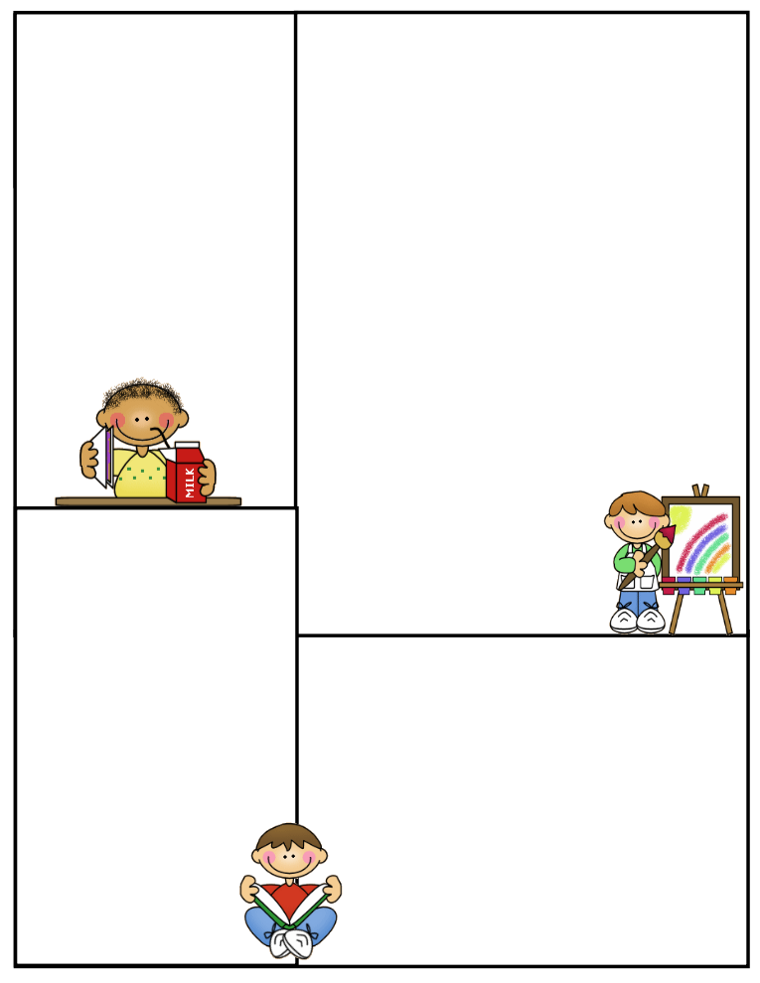

**Spelling words:**

**Commonly misspelled words in second grade**

**about first**

**a lot friend**

**and house**

**baseball little**

**because our**

**before said**

**they**

**I**

**then**

**Front Row**

**Word Study- ELA**

**All students are working at their own pace on phonics and comprehension. This program is a wonderful tool to use at home for improvement and becoming a successful reader. It creates stamina and allows for extra enrichment and adaptive practices. I highly recommend the continuation of this program over the summer.**

**What We’re Learning**

**Reading: Book Clubs Leveled reader books – Students will test their comprehension by taking an AR Test after their book is finished. Also, students are writing summaries on each chapter, as well.**

**(**[**www.reading.ecb.org**](http://www.reading.ecb.org)**) – go into the book and play games that practice reading strategies**

**Spelling: Test on Friday- most common misspelled words in second grade**

**Grammar: Acrostic poem on self-Review skills learned this year**

**Math: Review Packets on all the skills taught this year. Inquiry based math**

**Writing: Mechanics-sentence structure, & spelling- Journal writing**

**Science: Properties of different types of objects**

**Social Studies: Economics Opportunity Costs**

**(**[**www.kids.nationalgeographic.com**](http://www.kids.nationalgeographic.com)**) – learn about geography and fascinating animals**

**Computers: Type to Learn, Fact Dash, Front Row**

**Word study, ELA- Reading/Comprehension**

**Sight word bingo**

**(**[**www.abcya.com/dolch_sight_word_bingo.htm**](http://www.abcya.com/dolch_sight_word_bingo.htm)**)**

**Here are some sites the students can access to get extra practice in various areas.**

[**http://www.abcya.com/measuring.htm**](http://www.abcya.com/measuring.htm)

[**http://bigiqkids.comMeaurementGame.shtml**](http://bigiqkids.comMeaurementGame.shtml)

[**https://www.shepardsoftware.com/mathgames/menus/measurement.htm**](https://www.shepardsoftware.com/mathgames/menus/measurement.htm)

**Have a great weekend!**

**Terri**