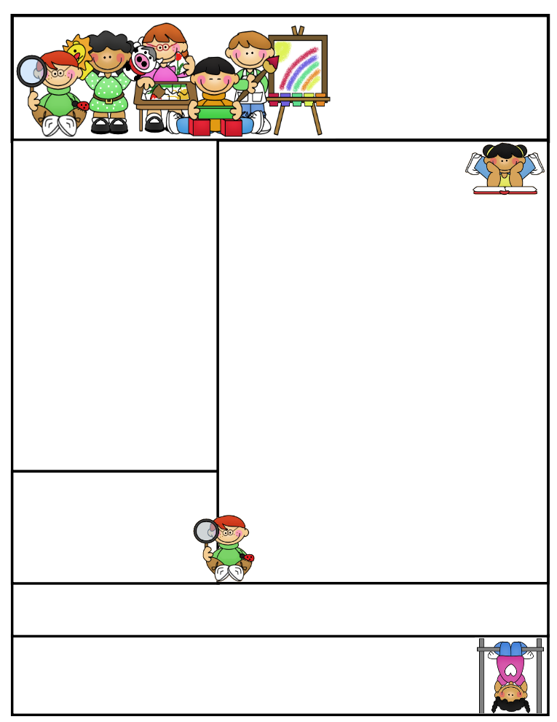

Classroom News

*There is no school on Friday, May 12th, due to Teacher In-service.*

The students did a great job on their Star Reading and Math Testing this week. It will be very important that your child continues to read over the summer, so they do not regress. Studies show that students lose three months if not more of the material he/she retained during the school year if their brains are not kept active and challenged with educational material. (Video games don’t count).

We candled the eggs on Tuesday morning to separate the fertile eggs from the non-fertile. We lost 8 eggs. The students were able to tell what eggs did not have a chick in them. They had lots of questions and were very good listeners. We should have some chicks this Tuesday! We can’t wait!

**Parents’ Night Out**

**When: Tuesday, May 23…school auditorium for instructions**

**Why: To learn useful strategies and** resources **to help your child succeed in school and make learning fun!**

***FREE: FOOD, BADGER CARE, & MORE…………***

**Agenda Books**

All agenda books need to be filled out, brought home, initialed, and sent back to school.

**Grandparents Program will be on May 31st at 1:00P.M.**

**Second Grade  
Newsletter**

**May 11, 2017**

**Important Reminders**

**Badger Summer Camp will include *FREE breakfast* and *FREE lunch*. *Everyone* is WELCOME to attend. The camp will run the week of July 24th-27th and July 31st- August 3rd. Breakfast is at 7:30 and camp starts at 8:00A.M. through 12:00P.M. Lunch will then be provided. Informational sheet in folder last week.**

[](http://www.bing.com/images/search?q=sun+images&id=0B8F48D11D6C3555BC82A602BF5F5B6E54506B3F&FORM=IQFRBA) [](http://www.bing.com/images/search?q=sun+images&id=0B8F48D11D6C3555BC82A602BF5F5B6E54506B3F&FORM=IQFRBA)

Let the warm weather begin and stick around! Students may bring in water bottles to have in class. A happy student is a hydrated student. Only plain water may be in the bottle.

**Literacy Tips: Have students practice their spelling in clay, using magnetic letters, or typing them on a computer. Read with your child daily to ensure he/she is being fluent and understanding what is being read. Reading books and/or library books should be coming home to practice reading daily.**

**Math Tips: All students have been added to a new math program call “front row.” *Students***

***can access the program from home and continue where they left off.* The classroom code is**

**3s3trg. This is a great way to work on all skills learned thus far and MATH FACTS!**

**All students need to work on addition and subtraction facts. Let’s go second graders!!!**

Math Tip:

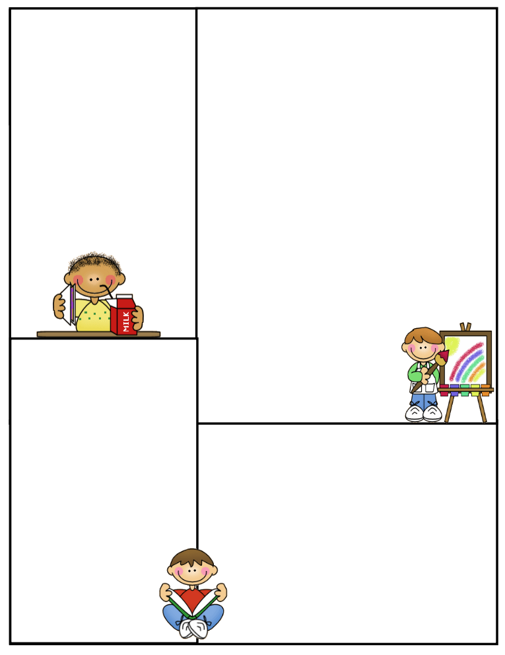

**Spelling words: open syllables**

**no noble bacon relate**

**male female return lion**

**baby basic**

**Review:**

**little middle**

**Challenge: High Frequency Words**

**door order remember**

**Robust Vocabulary:**

**defend encounter locate**

**positive react**

**Vocabulary Words:**

**glanced:** to look at something very quickly

**noble**: shows qualities of high moral

**gleamed:** shone or glowed

**promised:** to do something you said you would definitely do it

**wiggled:** moved from side to side

**What We’re Learning**

**Reading: Book Clubs Leveled reader books – Students will test their comprehension by taking an AR Test after their book is finished**

**Reading Book: My Home in Alaska pgs. 288-289**

**Nutik, the Wolf Pup pgs. 290-309 AR TEST**

**(**[**www.reading.ecb.org**](http://www.reading.ecb.org)**) – go into the book and play games that practice reading strategies**

**Spelling: TEST on Tuesday due to shorten week**

**Grammar: adjectives & adjectives that compare**

**Daily warm-up…reading comprehension**

**Math: More Geometry and Review Packets on all the skills taught this year.**

**Writing: Mechanics-sentence structure, & spelling**

**Science: Properties of different types of objects**

**Heat It UP, Cool It Down Lab**

**Social Studies: Economics Opportunity Costs**

**(**[**www.kids.nationalgeographic.com**](http://www.kids.nationalgeographic.com)**) – learn about geography and fascinating animals**

**Computers: Type to Learn, Fact Dash, Front Row**

**Word study, ELA- Reading/Comprehension**

**Sight word bingo**

**(**[**www.abcya.com/dolch_sight_word_bingo.htm**](http://www.abcya.com/dolch_sight_word_bingo.htm)**)**

**Here are some sites the students can access to get extra practice in various areas.**

[**http://www.abcya.com/measuring.htm**](http://www.abcya.com/measuring.htm)

[**http://bigiqkids.comMeaurementGame.shtml**](http://bigiqkids.comMeaurementGame.shtml)

[**https://www.shepardsoftware.com/mathgames/menus/measurement.htm**](https://www.shepardsoftware.com/mathgames/menus/measurement.htm)

**Have a great weekend!**

**Terri**