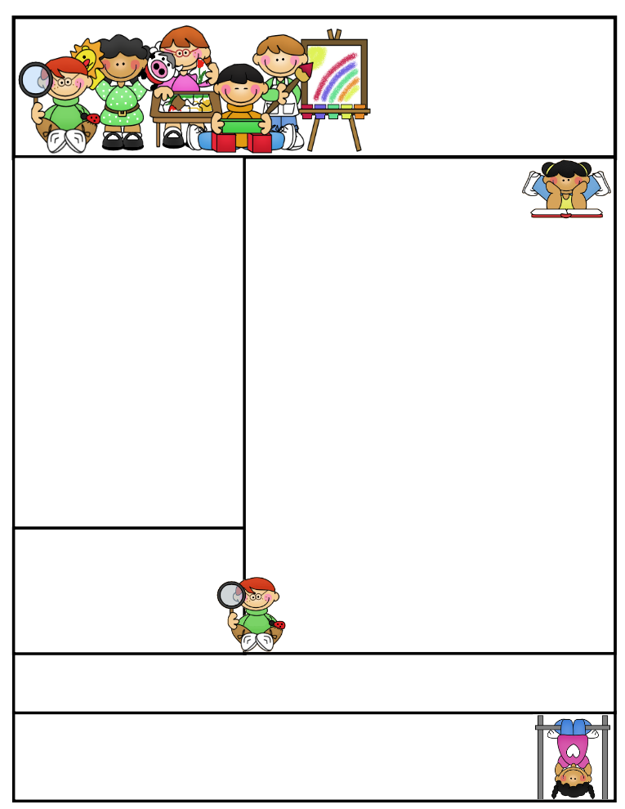

**Agenda Books**

**All agenda books need to be filled out, brought home, initialed, and sent back to school. Some students don’t have their agendas on a daily basis.**

Classroom News

**PALS TESTING: WEDNESDAY & THURSDAY**

**This week, Mrs. Sandy Anderson, brought in her incubator for hatching eggs. The students were given a presentation and able to place an egg or two into the incubator. We will candle the eggs in two weeks to see if the baby chicks will hatch. We are being very patient and good babysitters. The eggs will hatch in about three weeks. The students are very excited about this project and have already learned a handful of information. We are thankful Mrs. Anderson is giving us this opportunity to experience the life cycle of a chick and trust us as their caretakers.**

**Troy is still hanging out in our classroom. He is very easy to care for and never gets into any trouble. Troy is active mainly in the late afternoon and sleeps all day. The kids get to see him move around, but have yet to see him gobble his lettuce down. We are feeding him some of the lettuce we are growing in our room. It is like a jungle in here, but we surely enjoy our habitat!!**

**Important Reminders Badger Summer Camp will include *FREE breakfast* and *FREE lunch*. *Everyone* is WELCOME to attend. The camp will run the week of July 24th-27th and July 31st- August 3rd. Breakfast is at 7:30 and camp starts at 8:00A.M. through 12:00P.M. Lunch will then be provided. Informational sheet in folder.**

[](http://www.bing.com/images/search?q=sun+images&id=0B8F48D11D6C3555BC82A602BF5F5B6E54506B3F&FORM=IQFRBA)

**Second Grade  
Newsletter**

**April 28, 2017**

**Literacy Tips: Have students practice their spelling in clay, using magnetic letters, or typing them on a computer. Read with your child daily to ensure he/she is being fluent and understanding what is being read. Reading books and/or library books should be coming home to practice reading daily.**

**Math Tips: All students have been added to a new math program call “front row.” *Students***

***can access the program from home and continue where they left off.* The classroom code is**

**3s3trg. This is a great way to work on all skills learned thus far and MATH FACTS!**

**All students need to work on addition and subtraction facts. Let’s go second graders!!!**

Math Tip:

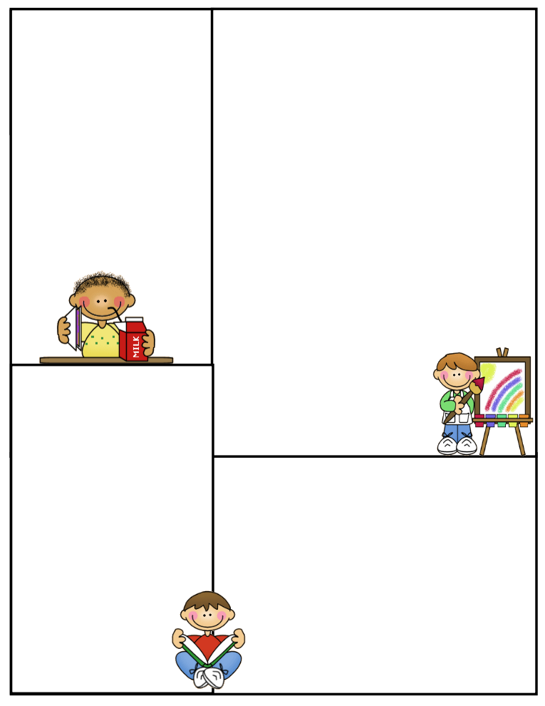

**Spelling words: r-controlled syllables**

**jump jumper**

**high higher**

**star starry**

**other mother**

**ever paper**

**Review:**

**highway between**

**Challenge: High Frequency Words**

**pulled travel voice**

**Vocabulary Words:**

agreed-thinking the same way

gathered-something that is brought together

jabbing-poking something with a pointed object

randomly- no plan or purpose

signal- a sign you are supposed to do something

**What We’re Learning**

**Reading: Book Clubs Leveled reader books – Students will test their comprehension by taking an AR Test after their book is finished**

**Reading Book: Why Sun and Moon Live in the Sky pg. 440-441**

**Pushing Up the Skypgs.442-455**

**(**[**www.reading.ecb.org**](http://www.reading.ecb.org)**) – go into the book and play games that practice reading strategies**

**Spelling: r-controlled syllables**

**Grammar: adjectives & adjectives that compare**

**Daily warm-ups …reading comprehension**

**Math: two dimensional shapes – faces, sides, & vertices**

**Writing: Mechanics-sentence structure, & spelling**

**Science: Solids, Liquids, & Gases - properties**

**Social Studies: Economics Goods/Services/Needs/Wants**

**(**[**www.kids.nationalgeographic.com**](http://www.kids.nationalgeographic.com)**) – learn about geography and fascinating animals**

**Computers: Type to Learn, Fact Dash, Front Row**

**Word study, ELA- Reading/Comprehension**

**Sight word bingo**

**(**[**www.abcya.com/dolch_sight_word_bingo.htm**](http://www.abcya.com/dolch_sight_word_bingo.htm)**)**

**Here are some sites the students can access to get extra practice in various areas.**

[**http://www.abcya.com/measuring.htm**](http://www.abcya.com/measuring.htm)

[**http://bigiqkids.comMeaurementGame.shtml**](http://bigiqkids.comMeaurementGame.shtml)

[**https://www.shepardsoftware.com/mathgames/menus/measurement.htm**](https://www.shepardsoftware.com/mathgames/menus/measurement.htm)

**Have a great weekend!**

**Terri**