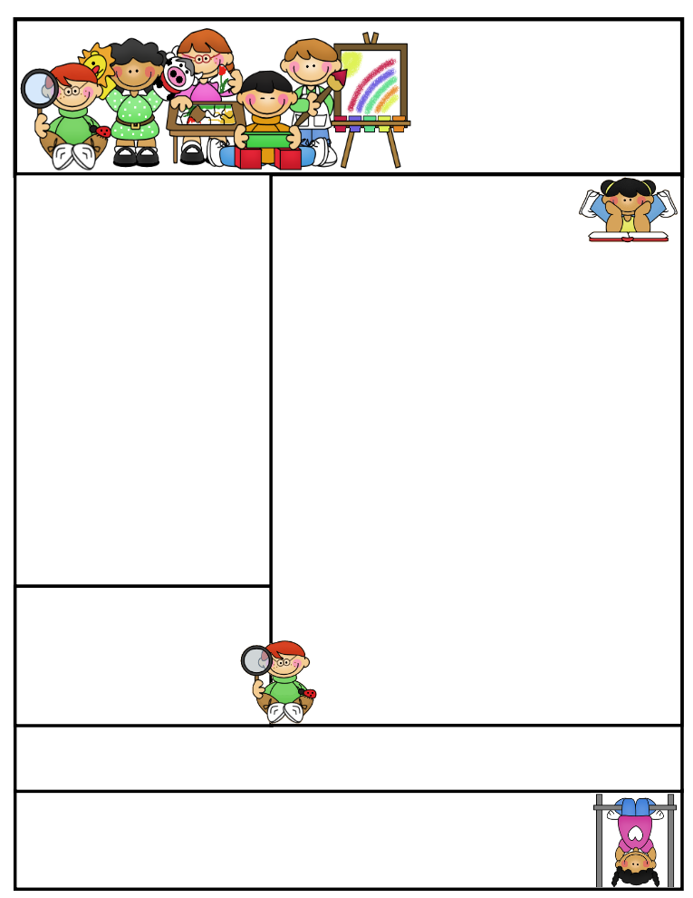

**Important Reminders**

**The end of the quarter was today. Report cards will be available on line next week. If you have any questions, please contact me by email or by phone.**

**This week we will be working on homophones in spelling. The students are familiar with most of the words, however there, their, and they’re prove to be difficult. Give each word in a sentence for clarification.**

**Second Grade  
Newsletter**

**March 24, 2017**

**Agenda Books**

**All agenda books need to be filled out, brought home, initialed, and sent back to school. Some students don’t have their agendas on a daily basis.**

**Literacy Tips: Have students practice their spelling in clay, using magnetic letters, or typing them on a computer. Read with your child daily to ensure he/she is being fluent and understanding what is being read. Reading books and/or library books should be coming home to practice reading daily.**

**Math Tips: All students have been added to a new math program call “front row.” *Students***

***can access the program from home and continue where they left off.* The classroom code is**

**3s3trg. This is a great way to work on all skills learned thus far and MATH FACTS!**

**All students need to work on addition and subtraction facts. Let’s go second graders!!!**

Math Tip:

Classroom News

Homophones

1. **“I can see Troy eating his lettuce,” said Kael.**
2. **“The sea is bright blue,” said Grace.**
3. **“There is a brown bear,” whispered Zowie.**
4. **“I like walking in my bare feet,” said Abbie.**
5. **Corey dug a deep hole in the backyard.**
6. **Owen and Sawyer ate the whole pizza.**
7. **Alexis turned eight this year.**
8. **“I ate my whole sundae,” said Shelby.**
9. **“I read 2 chapters last night for AR,” exclaimed Lexi.**
10. **“My favorite color is red,” said Reid.**
11. **“Our test is next week,” said Katara.**
12. **Dylan wants to leave in one hour.**
13. **“My book is over there,” exclaimed Ina.**
14. **“Their cake is the best in town,” said Saylor.**
15. **“They’re going on vacation soon,” said Kyle.**

**Please start studying now.**

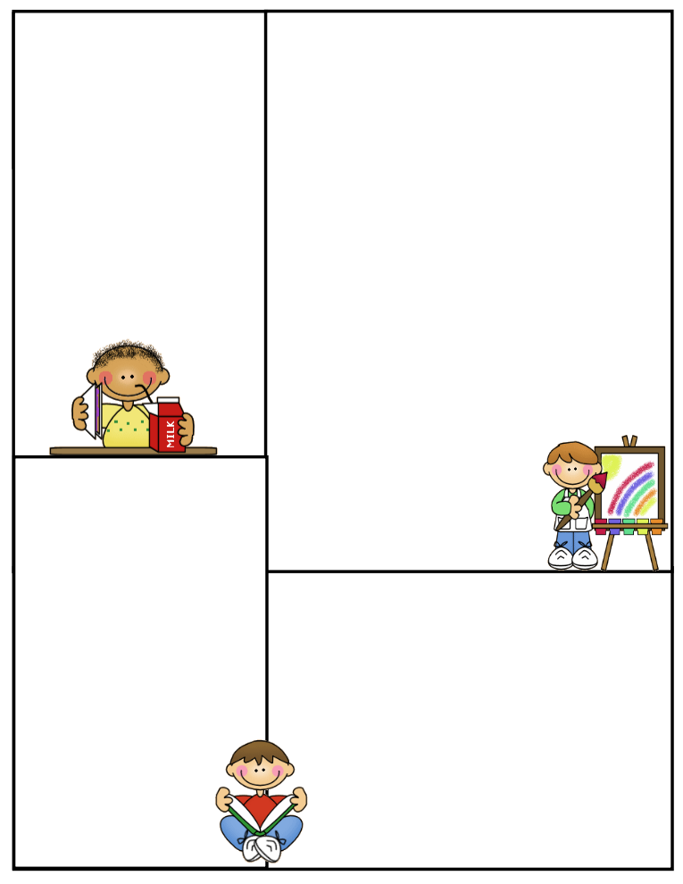

**What We’re Learning**

**Reading: Book Clubs Leveled reader books – Students will test their comprehension by taking an AR Test after their book is finished**

**Girls Against Boys by Phyllis Naylor *I am reading this book to the students. We play a comprehension game for review. We discuss the book thoroughly before the students take their quiz.***

**Spelling: Homophones- List and sentences on front**

**Grammar: Adjectives**

**Math: Graphs/Project Measurement-please practice using the sites listed on the back of this newsletter. Students will have to convert inches into feet and yards on their upcoming test.**

**Writing: Mechanics-sentence structure, & spelling**

**Narrative Planner / editing / Final Copy**

**Science: fast changes –natural disasters**

**Social Studies: Layers of the Earth-water on Earth**

**Computers: Type to Learn, Fact Dash, Front Row**

**Word study, ELA- Reading/Comprehension**

**Sight word bingo**

**(**[**www.abcya.com/dolch_sight_word_bingo.htm**](http://www.abcya.com/dolch_sight_word_bingo.htm)**)**

**(http.www.mathgametime.com/games/grand-prix-multiplication)**

Know and Label parts of the earth- crust, mantle, & core

Volcano- crater, central vent, & magma chamber

Fast and slow changes that occur in nature which shape the earth

Slow-streams, rivers, glaciers, wind

Fast-volcanoes, mudslides, volcanoes, hurricanes

Advantages volcanic activity:

New land, rich soil, good crops, & geothermal heat-electricity

Disadvantages: ash & dust, destroyed land, ground shifts & shakes, buildings sway & trees fall

Reading: Continue with

**“Prairie Problem” pgs.396-397**

**“A Way to Help Planet Earth” pgs. 398-401**

**Time for Kids “Water Trouble” pgs. 402-403**

Math Concepts

12 inches = 1 foot

3 feet = 1 yard

36 inches = 1 yard

Students need to know for test.

**Here are some sites the students can access to get extra practice in various areas. I highly suggest the measurement sites on converting from inches to feet to yards. This is difficult for most, as expected.**

**(**[**http://www.abcya.com/measuring.htm**](http://www.abcya.com/measuring.htm)

**(**[**http://bigiqkids.comMeaurementGame.shtml**](http://bigiqkids.comMeaurementGame.shtml)

**(**[**https://www.shepardsoftware.com/mathgames/menus/measurement.htm**](https://www.shepardsoftware.com/mathgames/menus/measurement.htm)

**Have a safe weekend!**

**Terri Johnson**