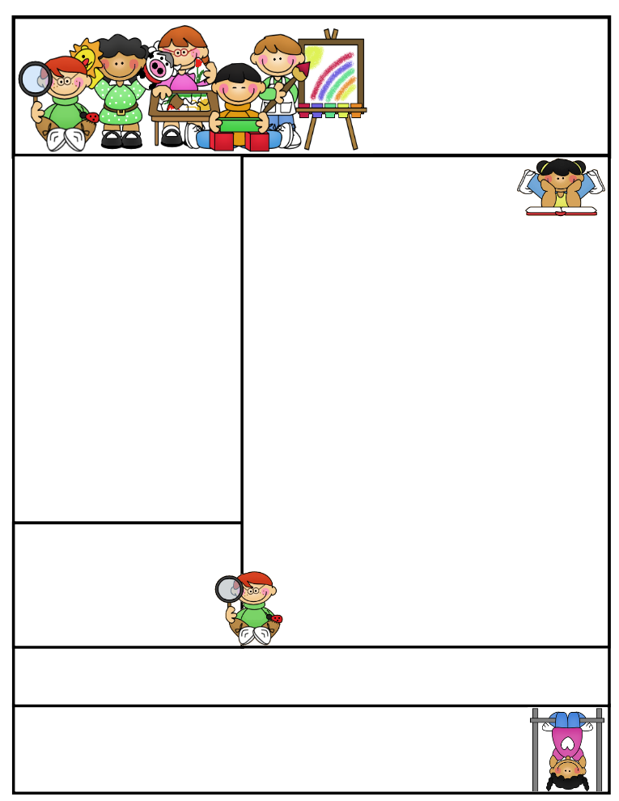

**Agenda Books**

**All agenda books need to be filled out, brought home, initialed, and sent back to school. Some students don’t have their agendas on a daily basis. I will be rewarding those who comply and giving consequences to those who don’t**. **Responsibility is important!**

**Literacy Tips:** Have students practice their spelling in clay, using magnetic letters, or typing them on a computer. Read with your child daily to ensure he/she is being fluent and understanding what is being read. **Reading books and/or library books should be coming home to practice reading daily.**

**Math Tips:** All students have been added to a new math program call **“front row.”** *Students*

*can access the program from home and continue where they left off.* **The classroom code is**

**3s3trg.** This is a great way to work on all skills learned thus far and **MATH FACTS!**

**All students need to work on addition and subtraction facts. Let’s go second graders!!!**

Math Tip:

Classroom News

A Winter Conference Slip is attached to this

Newsletter. Please let me know if the time doesn’t work for you and we will reschedule. Otherwise, I ‘ll assume I will see you then.

**Please remember to check your child’s agenda book for work that needs to be completed and sent back to school. If your child has corrections and I didn’t get a chance to work with him or her, I will send the paper home to be completed. I don’t enter a grade until the work has been corrected. A few students keep “forgetting” to bring their work back and have to completely redo the assignment during their recess time.**

**I have started testing students on the seven continents and 5 oceans. The students are practicing hard on the various manipulatives provided. If I give a pretest and feel your child could do better, I will make him/her study more before their final test. All students have a study guide with the continents and oceans labeled. Hopefully, you have seen this sheet come home. If not, you may want to ask where it is.**

**We will continue with wind erosion in science. We will discuss how wind can cause erosion to land and what engineers do to prevent mass destruction. Students will become engineers, research and create a model to prevent wind erosion. It will be interesting to see how their little minds work. We will then begin to study natural disasters. This will tie into how the continents were created.**

**We are working on Types of Graphs in Math. All students will be responsible for creating the four types of graphs we are currently studying. This project will be worth 4 grades in math.**

**Second Grade  
Newsletter**

**February 10, 2017**

**Important Reminders**

**Please keep sending in box tops! It is a great way to support your school and allow all the extras to be provided to the students. A new slip for the month of February is in your child’s folder.**

**Thank you very much to everyone who helped out during the sledding party or for the whole day. You are greatly appreciated!**

**Our Valentine’s Party will be on Tuesday. February 14th.A class list is on the back of the newsletter. We will be having root beer floats after library ;)**

**Of course, opening Valentine’s too!**

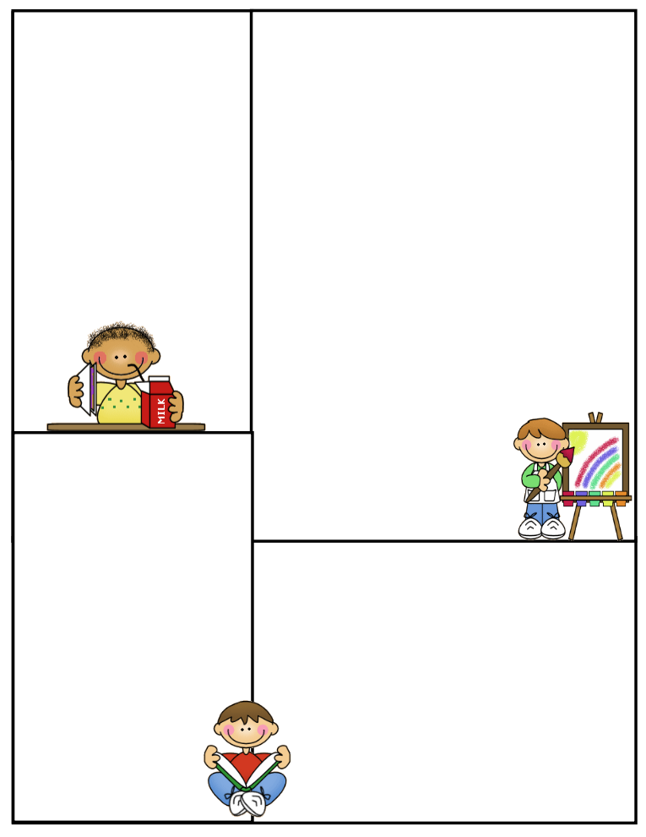

**Spelling words**

**au aw**

**pause law jaw**

**launch raw crawl**

**fault hawk draw**

**sauce**

**Review:**

**good could**

**High-Frequency:**

**decided bought among**

**There are some hard words this week. Please start studying this weekend.**

**Reading Vocabulary:**

Valentine List

1. Saylor Anderson
2. Caden Barr
3. Alexis Cramer
4. Owen Dunkes
5. Katara Garvaglia
6. Ina Holt
7. Corey Jensen
8. Lexi Johnston
9. Kyle Kay
10. Zowie Loukus
11. Grace Payette
12. Sawyer Rouse
13. Abbie Rug
14. Reid Schroeder
15. Kael Smith
16. Dylan Venstra
17. Shelby Zittlow

**What We’re Learning**

**Reading: Book Clubs Leveled reader books** – **Students will test their comprehension by taking an AR Test after their book is finished.**

**Reading book**: Mice and Beans- AR Test

**Phonics/Spelling: au & aw patterns**

**Grammar:** **past tense of verbs, quotation marks, & Pronouns**

**Math:** **Graphs/ Project**

**Writing:** **Mechanics-sentence structure**

**Journal Writing: 3 paragraphs**

**Science: Wind erosion / Design a model**

**Social Studies: Natural Disasters**

**Computers:** **Type to Learn, Fact Dash, Front Row**

**Word study, ELA- Reading/Comprehension**

Thank you for all you do to make your child successful!!

Have a great weekend!

Terri Johnson