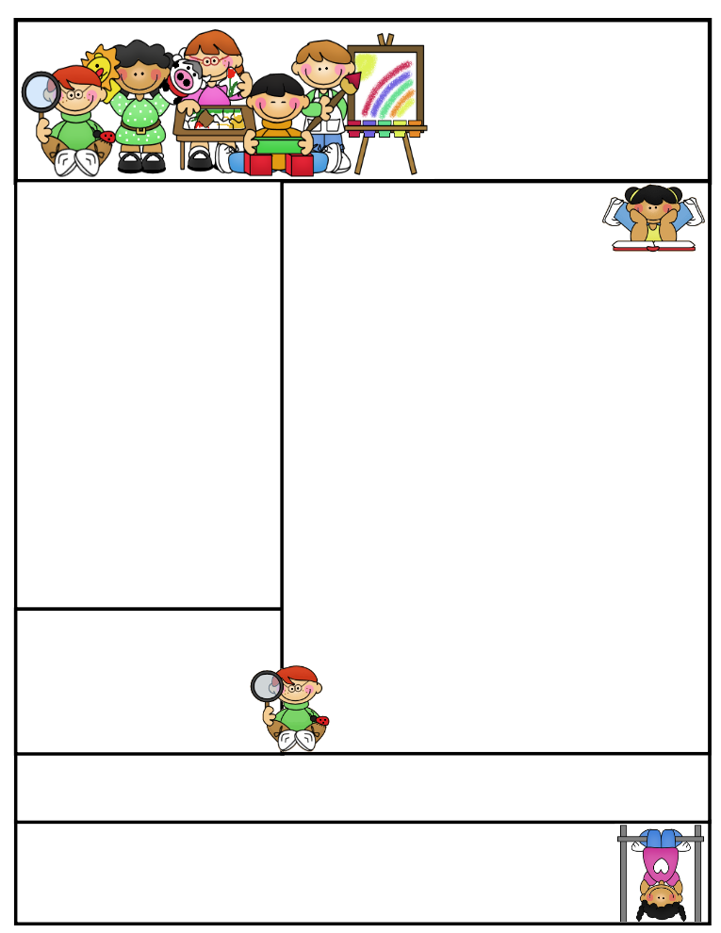

**Important Reminders**

**We have officially started quarter 4. I am in “awe” on how fast this year is flying and how much these children have grown throughout the year socially and academically.**

**This summer I will be teaching a section in summer school. Please consider sending your child if at all possible. There is further information coming on the dates, time, and offerings. I am really excited for this adventure. All students are welcome.**

**This week we will be working on more homophones in spelling. The students are familiar with most of the words. Give each word in a sentence for clarification.**

**Second Grade  
Newsletter**

**April 7, 2017**

**Agenda Books**

**All agenda books need to be filled out, brought home, initialed, and sent back to school. Some students don’t have their agendas on a daily basis.**

**Literacy Tips: Have students practice their spelling in clay, using magnetic letters, or typing them on a computer. Read with your child daily to ensure he/she is being fluent and understanding what is being read. Reading books and/or library books should be coming home to practice reading daily.**

**Math Tips: All students have been added to a new math program call “front row.” *Students***

***can access the program from home and continue where they left off.* The classroom code is**

**3s3trg. This is a great way to work on all skills learned thus far and MATH FACTS!**

**All students need to work on addition and subtraction facts. Let’s go second graders!!!**

Math Tip:

Classroom News

Homophones

1. **“I know the answer to the question,” said Kael.**
2. **“The answer is no,” replied Grace.**
3. **“There are two turkeys in the field,” yelled Zowie.**
4. **“I want to go to summer school,” said Abbie.**
5. **Corey replied, me too, Abbie!”**
6. **Owen and Sawyer would go if their parents send them.**
7. **Alexis helped cut wood this weekend.**
8. **Shelby turned in her work when it was due.**
9. **“I will do my job all week,” exclaimed Lexi.**
10. **Is there dew on the grass?” said Reid.**
11. **“I think I saw a bee!” screamed Katara.**
12. **“I will be there in a minute,” Dylan said.**
13. **Ina yelled, “I got a new pair of shoes!”**
14. **“I knew that when I saw you Ina,” said Saylor.**
15. **“Shu fly don’t bother me,” sang Kyle.**
16. **“Step on it with your shoe, Ina!” yelled Mrs. J.**

**Please start studying now.**

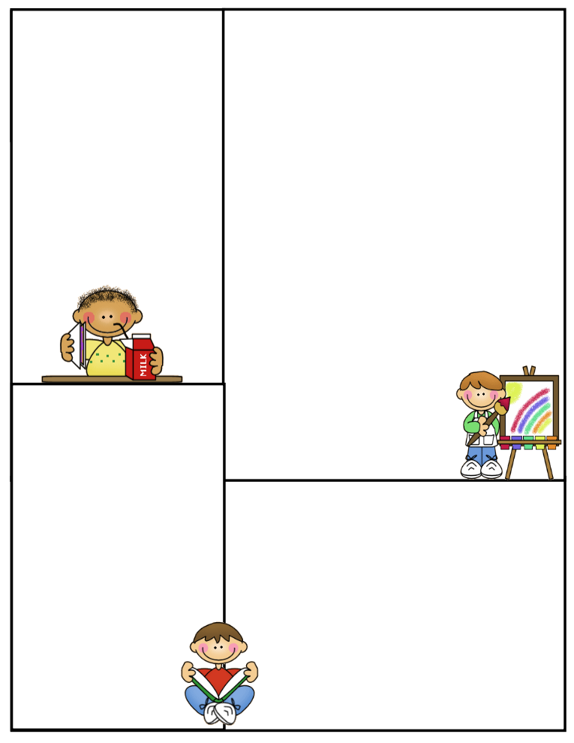

**What We’re Learning**

**Reading: Book Clubs Leveled reader books – Students will test their comprehension by taking an AR Test after their book is finished**

**Girls Against Boys by Phyllis Naylor *I am reading this book to the students. We play a comprehension game for review. We discuss the book thoroughly before the students take their quiz.***

**Spelling: Homophones- List and sentences on front**

**Grammar: Pronouns/ contractions / I**

**antonyms & synonyms**

**Math: Graphs/Project Measurement-please practice using the sites listed on the back of this newsletter. Students will have to convert inches into feet and yards on their upcoming test.**

**Writing: Mechanics-sentence structure, & spelling**

**Narrative Planner / editing / Final Copy**

**Science: Volcano experiment Model of Earth**

**Start Solids, Liquids, & Gases Water Cycle**

**Social Studies: Economics Goods/Services/Needs/Wants**

**Computers: Type to Learn, Fact Dash, Front Row**

**Word study, ELA- Reading/Comprehension**

**Sight word bingo**

**(**[**www.abcya.com/dolch_sight_word_bingo.htm**](http://www.abcya.com/dolch_sight_word_bingo.htm)**)**

**(http.www.mathgametime.com/games/grand-prix-multiplication)**

Know and Label parts of the earth- crust, mantle, & core

Volcano- crater, central vent, & magma chamber

Fast and slow changes that occur in nature which shape the earth

Slow-streams, rivers, glaciers, wind

Fast-volcanoes, mudslides, volcanoes, hurricanes

Advantages volcanic activity:

New land, rich soil, good crops, & geothermal heat-electricity

Disadvantages: ash & dust, destroyed land, ground shifts & shakes, buildings sway & trees fall

Reading: Reading Clubs

Water Problems/Recycle, Reuse….Poster

Math Concepts

12 inches = 1 foot

3 feet = 1 yard

36 inches = 1 yard

100 cm = 1 meter

Students need to know for test.

**Here are some sites the students can access to get extra practice in various areas. I highly suggest the measurement sites on converting from inches to feet to yards. This is difficult for most, as expected.**

**(**[**http://www.abcya.com/measuring.htm**](http://www.abcya.com/measuring.htm)

**(**[**http://bigiqkids.comMeaurementGame.shtml**](http://bigiqkids.comMeaurementGame.shtml)

**(**[**https://www.shepardsoftware.com/mathgames/menus/measurement.htm**](https://www.shepardsoftware.com/mathgames/menus/measurement.htm)

**Have a safe weekend!**

**Terri Johnson**