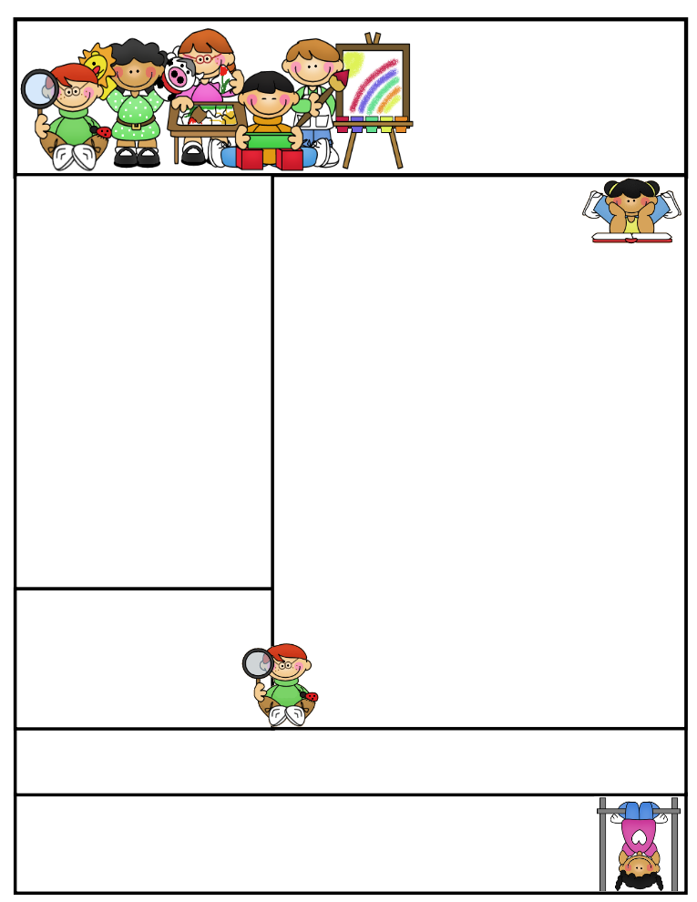

**Literacy Tips:** **Have students practice their spelling in clay, using magnetic letters, or typing them on a computer. Read with your child daily to ensure he/she is being fluent and understanding what is being read. Reading books and/or library books should be coming home to practice reading daily.**

**Math Tips:** All students have been added to a new math program call **“front row.”** *Students*

*can access the program from home and continue where they left off.* **The classroom code is**

**3s3trg.** This is a great way to work on all skills learned thus far and **MATH FACTS!**

**All students need to work on addition and subtraction facts. Let’s go second graders!!!**

Math Tip:

**Agenda Books**

**All agenda books need to be filled out, brought home, initialed, and sent back to school. Some students don’t have their agendas on a daily basis. I will be rewarding those who comply and giving consequences to those who don’t**. **Responsibility is important!**

Classroom News

**Please remember to check your child’s agenda book for work that needs to be completed and sent back to school. If your child has corrections and I didn’t get a chance to work with him or her, I will send the paper(s) home to be completed. I don’t enter a grade until the work has been corrected. A few students keep “forgetting” to bring their work back and have to completely redo the assignment during their recess time.**

**Please return art shirts that were sent home to be washed. Only a couple of students have brought them back. I know that the students will be painting soon and wouldn’t want to see their clothes ruined.**

**The students did a wonderful job designing their landforms and testing on the model I created. I have them displayed in the room.**

**We will begin on the 7 continents and 4 oceans. Students will be given a study guide to color and practice on for their upcoming test.**

**I have two colored models with Velcro labels, a smart exchange activity, and erasable maps the students will use for practicing before I will test them.**

**We will continue with wind and water erosion in science. We will discuss how water can cause erosion to land and what engineers do to prevent mass destruction. Students will become engineers and research, brainstorm, design a model to lessen wind erosion.**

**We have been studying water erosion and the damage done to the landforms around. Ask your child about our “clay ball” experiment and sand experiment. We are also going through the 8 step process the DPI has adopted in support of the NGSS Standards taught throughout the curriculum.**

**We will continue to work on working on money in Math, as well as, regrouping. All students have 2 extra math packets to be working out of. Rules for regrouping were given to the students to use and a money packet with rhymes and touch points to help them count was also given.**

**1.Organize the money according to its value**

**2. Name and label the value of each coin**

**] 3.Count the money using a running total**

**Second Grade  
 Newsletter**

**February 6-10, 2017**

**Important Reminders**

**The PTO is giving a Box Top sledding reward party to each of the elementary grades and 6th grade.**

**Second graders will sled on Tuesday, February 7th from 11:30-12:30. Thank you to Mr. Zittlow and Mrs. Payette for volunteering to help out. Also, Dylan’s Grandpa may sled with us too!**

**Please keep sending in box tops! It is a great way to support your school and allow all the extras to be provided to the students.**

**Grace Payette brought in 110 box tops this week! Wow! Dylan and Ina brought in sheets, as well. Great job second graders!! We are “Top” Notch!**

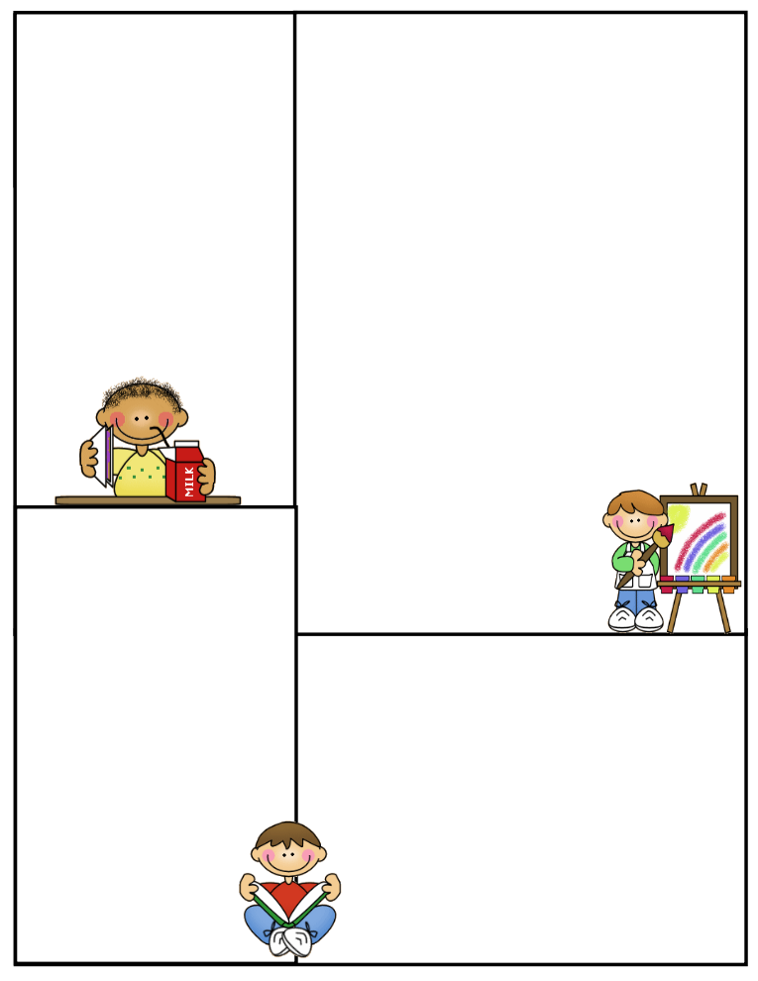

**What We’re Learning**

**Reading: Book Clubs** Leveled reader books – **Students will test their comprehension by taking an AR Test after their book is finished. ELA on front Row- Assigned articles to read and answer questions.**

**Phonics/Spelling: words with oo & ou**

**Grammar:** **Linking verbs- Forms of be: is, am & are**  **Past tense of be**: **am *is* was** **is *is* was** **are *is* were have and has**

**Math:** **Types of Graphs and how to read each. Students will create 4 graphs for 100 points each…Details and examples to follow.**

**Writing:** Mechanics-sentence structure

**Journal Writing:** 3 paragraphs

**Science: locate/ label the 7 continents and 4 oceans- Students have a study guide**

**Erosion- Continue Water and Wind- Experiments**

**Social Studies:** Students have flashcards to help them study for their communities’ test. They should have gone home this weekend

**Computers:** Type to Learn, Accelerated Math,

Math Facts in a Flash, and Accelerated Reading &

Front Row

Reading Vocabulary will vary according to Book Club level and book(s) being read.

Journal writing will include higher requirements and maybe coming home to complete if not completed during class. Many students want to write only a minimal amount or nothing at all. Please be on the “lookout” for journal entry in daily agenda or backpack.

**Spelling words**

**oo ou*__________***

**shook should**

**hook could**

**crook would**

**good**

**brook**

**foot**

**soot**

**Review:**

**fruit glue**

**High-Frequency:**

**below city own**

**Reading Vocabulary:**

**Thank You**

I know everyone is busy and this is a fast paced life we are all living in, but wanted to let you know how much I enjoy the students, their work ethic, and all the extra help you give them at home!!

Have a great weekend!

Terri Johnson